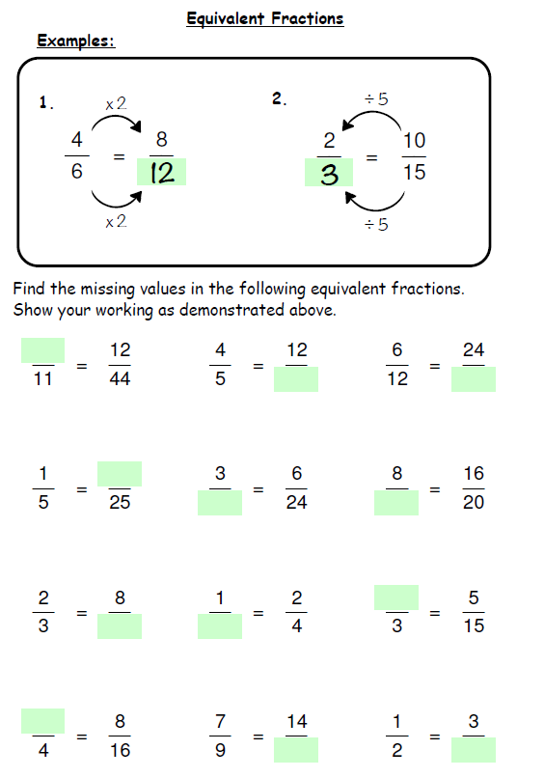
Extension Problem solving

1) All of these fractions may be written with a denominator of 60. Write them all as sixtieths and then rewrite the list in ascending order. Your answer should contain the fractions in their original form.
$\frac{17}{30}$ $\frac{1}{2}$ $\frac{7}{15}$ $\frac{3}{5}$ $\frac{9}{20}$ $\frac{4}{10}$

2) Find a fraction equivalent to $\frac{4}{9}$ in which the sum of the numerator and denominator is 156.

