Willow class homework- English Date- 30/9/22
L. O. To add ‘er’ and ‘est’ to adjectives where no change is needed to the root word.

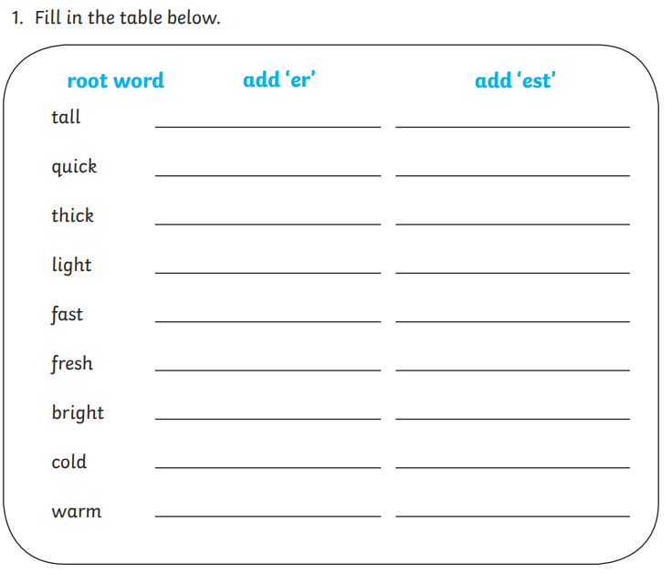
Now, choose three of the words from the table and put them into separate sentences in your book. Don’t forget capital letters and full stops.
Challenge; Can you include two of the words in one sentence?

