Willow class homework- English Date- 30/9/22
L. O. To add the suffix ‘ment’ and ‘ness’.
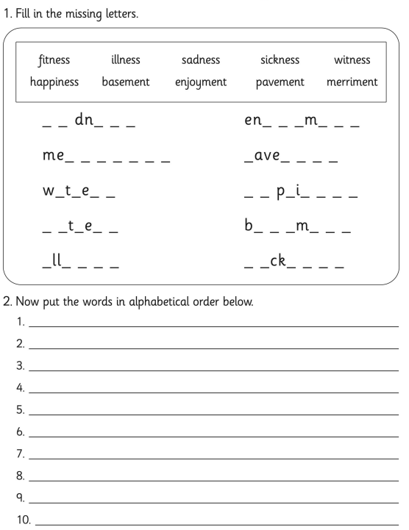

Now, choose four of the words from above and put them into separate sentences in your book. Don’t forget capital letters and a piece of punctuation at the end of every sentence.
Challenge; Can you include two of the words in one sentence?

