Mosaic Partnership Trust

55 Use of Reasonable Force and Restrictive Intervention Policy (Ref: MPTRPI)

Version 1.0

Policy Name | Use of Reasonable Force and Restrictive Intervention Policy
Policy Reference | MPTRPI
Version | V1.0
Date Created/Amended | 01/09/2026
Date Approved | 07/09/2026
Policy Author | Caroline Carter and Libby Lines
Approved By | Executive Leadership with oversight from QEC
Review Cyle | Annually
Review Date | 01/09/2026
Trust Board For Info. | 30/09/2026 (Board for Information)

Version | Date | Page | Change | Origin of Change
V1.0 |  | Whole Document | Adoption by the Mosaic Partnership Trust and Implementation | New Academy Trust requirement of a Use of Reasonable Force and Restrictive Intervention Policy

Heading | Page
1. Purpose and Strategic Context | 4
2. Key Principles | 4
3. Terminology and Definitions | 5
4. Prevention and De-escalation (Core Approach) | 6
5. Legal Powers | 7
6. When Force May Be Used | 7
7. The “Reasonableness” Test | 8
8. Consideration for Children with SEND | 8
9. Training and Risk Assessment | 9
10. Prohibited Practices and Risk Management | 9
11. Seclusion | 10
12. Use of Force for Searching | 11
13. Recording of Incidents (Statutory Requirement) | 11
14. Reporting to Parents/Carers (Statutory Requirement) | 12
15. Post-Incident Support and Review | 12
16. Monitoring and Governance | 13
17. Complaints and Allegations | 14
18. Related Policies | 14
19. Local Implementation Details | 14
Appendix 1: Exemplification of Prompts, Guides and Holds | 15
Appendix 2: Record of Use of Restrictive Physical Intervention Form | 19
Appendix 3: Independent Incident Review | 22
Appendix 4: Pastoral Support Plan Review | 24
Appendix 5: Letter to Parents following Restrictive Physical Intervention incident | 25
Contents

1. Purpose and Strategic Context
This policy sets out the legal, ethical and professional framework for the use of reasonable force and other restrictive interventions within the school in the wider context of the Mosaic Partnership Trust of which the school is a part. This policy therefore is a Trust policy and operates across the Trust Estate.
The school is committed to:
- Safeguarding and promoting the welfare of all children
- Protecting the safety and wellbeing of staff
- Minimising the need for restrictive interventions through prevention, early support and de-escalation
This policy reflects statutory duties under:
- Education and Inspections Act 2006 (Sections 93 & 93A)
- Health and Safety at Work etc. Act 1974
- Human Rights Act 1998
- Equality Act 2010
This policy must have regard to the DfE guidance (active from 1st April 2026) on the use of reasonable force and restrictive interventions.
2. Key Principles
- The use of force is a last resort
- Force must never be used as punishment
- The least restrictive option must always be used
- Interventions must be:
  - necessary
  - proportionate
  - reasonable in the circumstances
- The dignity, wellbeing and rights of the child must remain a priority at all times
- The school adopts a preventative, relational and trauma-informed approach
The school will not operate a “no contact” policy, as this could prevent staff from fulfilling their duty of care.

3. Terminology and Definitions
The school uses the following definitions in line with DfE guidance:
Restrictive Interventions
Any planned or reactive action that limits a child’s movement, liberty or freedom to act independently.
This may include physical, mechanical, chemical (a form of medical restraint) or environmental restriction.
A ‘plain English’ definition for a restrictive intervention is one in which a person is prevented from doing what they appear to want to do.
Reasonable Force
Reasonable Force is a legal test, used to determine if force - usually a physical contact - used by staff to control or restrain a child’s actions is justifiable under law.
Force must be necessary and therefore used for the least amount of time. It must be proportionate to the circumstances it is attempting to prevent or stop.
Restraint
A form of restrictive intervention involving direct physical contact intended to prevent, restrict or subdue movement.
Seclusion
The supervised confinement and isolation of a child, away from other children, in an area from which the child is prevented from leaving of their own free will.
Important Note
These categories are not mutually exclusive and may overlap depending on the circumstances.
Significant Incident
‘Significant incident’ refers to any incident where the use of reasonable force goes beyond appropriate physical contact between children and staff.
Appropriate Physical Contact
There are circumstances when it is appropriate for staff to have some physical contact with children which does not give rise to any question over the use of reasonable force and other restrictive interventions. This will depend on the circumstance, but examples of occasions when physical contact is generally appropriate include giving first aid, guiding children, comforting a distressed child, congratulating or praising a child (for example, a pat on the back or a handshake), demonstrating how to use a musical instrument, and demonstrating exercises or techniques during PE lessons or sports coaching.
In assessing whether physical contact is appropriate in a given situation, the member of staff should use their judgement, have regard to the Trust’s Safeguarding and Child Protection Policy, the applicable circumstances (including whether there are other adults present), the individual child’s age, and any other material factors. This includes, but is not limited to, whether the child has SEND or other vulnerabilities (See Trust SEND Policy), and whether any alternative strategies which do not include physical contact can be used.
Risk Assessment
A risk assessment is a suitable and sufficient process for identifying hazards and judging the level of risk by weighing:
- frequency (likelihood): how often the harmful event could happen, given the context and triggers.
- severity (impact): how serious the harm could be if it happens, for everyone affected.
It then records the controls needed to reduce the risk to a level that is reasonably practicable, balancing the level of risk against the time, effort, and resources required to reduce it. Carrying out Risk Assessments is a duty under Health and Safety management regulations and in line with the Trust Health and Safety Policy.

4. Prevention and De-escalation (Core Approach)
The school prioritises preventing situations that may lead to the use of force.
Whole-School Measures
The school promotes a positive behaviour culture built on clear expectations that are explicitly taught, consistently reinforced, and applied fairly. This includes shared language for behaviour, predictable routines, and proportionate responses that support learning and help children understand what good order and discipline look like in practice.
The school also maintains safe, supportive learning environments that reduce unnecessary stressors and help children regulate and engage. This includes thoughtful classroom and corridor expectations, supervision in higher-risk spaces, and proactive adjustments for children who may be more vulnerable to distress, sensory overload, or anxiety.
Staff are trained and supported to use prevention and de-escalation as the default approach.
Training focuses on de-escalation skills, effective communication strategies, and practical ways to support emotional regulation, so that staff can recognise early warning signs, respond calmly, and reduce the likelihood that situations escalate.
Strong staff–child relationships are treated as a core protective factor. Staff are expected to build trust through consistent, respectful interactions, to repair relationships after incidents, and to use relational approaches that preserve dignity, particularly when a child is distressed.
The school maintains consistent behaviour systems so that children experience predictable boundaries and staff responses are aligned across teams. Finally, the school regularly reviews incident and behaviour data to identify patterns, triggers, and any disproportionality. Learning from this data is used to improve practice, target training, and strengthen preventative planning. Behaviour data must be available for the Trust whereby there is a monitoring across the Trust schools to ensure consistency.
De-escalation Strategies
Staff will, wherever possible:
- treat others with dignity by showing them respect in their communication
- be sensitive to behaviour triggers and environmental stressors
- adjust tone, body language and proximity
- listen with empathy
- offer choices and time to process
- redirect attention
- seek support from colleagues

5. Legal Powers
Under Section 93 of the Education and Inspections Act 2006, all school staff have the legal power to use reasonable force.
This includes:
- teachers and support staff
- any person authorised by the Headteacher
The school does not accept requests by parents or staff members not to use reasonable force and/or other restrictive interventions.

6. When Force May Be Used
Force may only be used to prevent a child from:
- causing injury to themselves or others
- committing a criminal offence
- damaging property
- seriously disrupting good order and discipline

7. The “Reasonableness” Test
Staff must apply professional judgement using the following framework:
1. Necessity
- Is there an imminent risk of harm?
- Can the situation be verbally de-escalated?
- Can the team wait or withdraw from the situation?
- Are there any other viable options rather than use of force?
2. Proportionality
- A proportionate amount of force prevents a greater harm from occurring.
3. Welfare and Dignity
When making decisions about any physical contact, staff must actively consider the child ’s welfare and dignity throughout the incident. This means taking account of the child’s age and size, any medical needs, any special educational needs and/or disabilities (SEND), and any known history of trauma, distress, or vulnerability that may affect how the child experiences the intervention.
Staff must also consider the child’s communication needs. Where a child has speech, language and communication needs, is non-verbal, or has English as an additional language, staff should use clear, calm language and appropriate non-verbal strategies, and allow time for the child to process what is being communicated.
Where possible, staff should seek to maintain respect for a child’s dignity. This may include, where possible, considering the location and environment where any intervention is used, such as in front of their peers. Staff should explain what is happening and why, using simple, respectful language, and should continuously monitor the child’s wellbeing so that the level of intervention can be reduced or stopped as soon as it is safe to do so.

8. Considerations for Children with SEND
The school recognises that children with SEND may be disproportionately affected.
The school will identify individual triggers that can increase the likelihood of distress or escalation, including sensory overload, anxiety, and pain, and will respond by putting proactive and preventative strategies in place. Where a child may be more vulnerable, the school will work in co-production with parents, the child, and relevant professionals to agree supportive approaches and clear planning. The school will also ensure that reasonable adjustments are identified, implemented, and reviewed so that the child can be supported effectively and the need for restrictive intervention is reduced wherever possible.

Pastoral Support Plans (PSPs)
Where risk is identified, plans will include:
- Triggers and early warning signs
- De-escalation strategies
- Agreed responses
- Any agreed physical interventions (if applicable)
Plans will be reviewed:
- Regularly
- After any significant incident

9. Training and Risk Assessment
The school will:
- ensure all staff likely to use force are adequately trained in the safe and lawful use of restrictive interventions and in preventative strategies
- ensure training reflects the principles set out in DfE guidance, including prevention, de-escalation, and the safe and lawful use of force.
- carry out risk assessments where there is foreseeable risk of intervention
- ensure staff understand:
  - Safe practice
  - Legal boundaries
  - De-escalation techniques

10. Prohibited Practices and Risk Management
Prohibited Practices and Safety Requirements
Staff must never:
- use force as a punishment
- use any technique that restricts breathing or circulation
- cover the mouth or nose
- apply pressure to the neck, chest, abdomen or ribcage

High-Risk Positions
- prone restraint (face-down) is prohibited
- ground restraint must be avoided wherever possible
If a child is unintentionally in contact on the ground, staff must:
- release or reposition immediately to a safer position (e.g. seated or standing)
- continuously assess the child’s condition
Risk Awareness (Breathing and Circulation)
Staff must be aware of the risks associated with restraint, including those relating to breathing and circulation (sometimes referred to as positional asphyxia).
Staff must:
- Monitor the child continuously
- Look for signs of distress (e.g. breathing difficulty, collapse, panic)
- Act immediately to reduce or stop the intervention if risk is identified. Staff must continuously assess the situation and reduce or cease the intervention as soon as it is safe to do so.
See Appendix 1 – Exemplification of Prompts, Guides and Holds for further information.

11. Seclusion
Seclusion is a non-disciplinary intervention involving keeping a child confined to a place away from others and prevented from leaving which should only be used as a safety measure to protect others from harm when a child is experiencing high levels of emotional or behavioural dysregulation. In such circumstances, the child is not acting with intent.
Seclusion should not be implemented by staff through threat of punishment.
The place to which the child is confined should be safe and not feel threatening or intimidating to the child.
The child should be supervised at all times during the period of seclusion.
As soon as the immediate risk of harm has reduced, the child should be allowed to leave.
An incident involving the use of seclusion must be recorded and reported. See Record of Use of Restrictive Physical Intervention Form (Appendix 2)

12. Use of Force for Searching

Force may be used to search a child, or their possessions, for prohibited items only, where there are reasonable grounds to suspect the child has such an item. This power applies to headteachers and to staff members they have authorised to carry out searches. These staff members will be adequately trained in the safe and lawful use of restrictive interventions and in preventative strategies. Searching of children must never be undertaken alone, only with another adult present and following authorisation from the Headteacher, unless the Headteacher who already carries the authorization to do so.

Prohibited items in schools are objects that pose a risk to safety, wellbeing, or the learning environment, including weapons, controlled drugs, prescription drugs, illegal drugs, stolen items, and other items banned by school policy that pose a genuine risk to safety.

Staff must not use force to search for items that are banned under school policy that do not pose a risk to safety (for example, mobile phones, toys or non-uniform items).

Where a search is required, staff should follow the school’s safeguarding procedures and have regard to relevant DfE guidance on searching, screening and confiscation.

13. Recording of Incidents (Statutory Requirement)

All significant incidents must be recorded on the Record of Use of Restrictive Physical Intervention Form (Appendix 2) as soon as practicable after the event by the staff member(s) involved.

The requirement to record applies even if the use of reasonable force and other restrictive interventions in certain circumstances is agreed with parents as part of a child’s Pastoral Support Plan.

As a minimum, records must include:

- names of child and staff directly involved

- any relevant needs or circumstances of the child, including whether the child has an identified special educational need or disability and their SEN status code

- time, date, location, and approximate length of time the intervention was used

- a brief account of the incident, including what led up to it, identified or potential triggers (if known), any preventative or de-escalation strategies used, what type of reasonable force was applied, the degree of force, and details of any physical injuries sustained (if applicable)

- a brief account of why the use of force was assessed as necessary in that instance

- any post-incident support, including details of any medical treatment for injuries or other adverse impacts

The school will also record additional details to support evaluation and learning, for example the child’s and/or witnesses’ accounts, when and how parents were notified, and what follow-up has taken place. (See the Mosaic Partnership Trust Behaviour Framework)

As a matter of best practice, the school will also record non-force restrictive interventions where a child’s freedom of movement or liberty is restricted beyond ordinary classroom management, in order to support monitoring, safeguarding and preventative practice.

14. Reporting to Parents/Carers (Statutory Requirement)
Parents/Carers must be informed as soon as practicable, verbally and then followed up with a letter, unless doing so would risk significant harm to the child.
See Appendix 5 – Letter to Parents/Carers following RPI incident.
Reports will include:
- time, date, location and duration
- type of force used
- any injuries
- reason for use
The requirement to report to parent/carers applies even where the use of reasonable force is anticipated or agreed as part of a Pastoral Support Plan.
Where reporting to parents/carers is not appropriate, the incident will be reported to the Local Authority.

15. Post-Incident Support and Review
Following any significant incident, the school will take prompt action to support the wellbeing of the child, any staff involved, and the wider school community, and to reduce the likelihood of recurrence. The purpose of the post-incident process is to ensure any immediate health needs are met, that recording and reporting duties are fulfilled, and that the school learns from what happened in a way that protects dignity, rebuilds relationships, and strengthens preventative practice.
As soon as practicable after the incident, staff must consider whether the child or any member of staff requires a medical assessment or treatment for injury. Any injuries must be recorded in line with the school’s procedures and escalated where required. In the context of staff – the school must refer to the relevant Trust Policy if appropriate: Preventing & Dealing with Violence & Assaults Towards Staff.
Support will be offered to the child, to any staff involved, and, where appropriate, to witnesses who may have been distressed by what they saw or heard. This support will be proportionate to need and may include reassurance, time and space to regulate, and follow-up conversations, as well as access to additional pastoral or wellbeing support where required.
A debriefing process will be completed to support reflection and learning. See Appendix 3 - Independent Incident Review
This should include separate opportunities for the staff member(s) involved and the child to share their reflections. Where possible, the debrief should be facilitated by a member of staff who was not directly involved in the incident and may include an additional person to support impartiality. The debrief should focus on understanding what happened, what contributed to escalation, what helped, and what could be done differently in future. A specific aim of the process is to repair and rebuild relationships through respectful dialogue.
Following the debrief, the school will review any relevant Pastoral Support Plan (PSP) or other planning documents. The review will identify preventative improvements, including adjustments to support strategies, environments, staffing approaches, communication plans, or risk management measures, and will ensure these changes are communicated to the relevant staff.
See Appendix 4: Pastoral Support Plan Review.

16. Monitoring and Governance
The school leadership team will:
- review incident data three times a year to:
  - identify patterns
  - improve practice
  - identify training needs
  - monitor disproportionality
- ensure compliance with statutory duties
- ensure compliance with this policy
A review at Trust level will be conducted three times a year (termly) by:
- The trust Strategic Lead for SEND and Inclusion
Trustee oversight will come through the Safeguarding Trustee, where information on high level trends is provided termly by the Strategic Lead for SEND and Inclusion based on the information from the review.

17. Complaints and Allegations
Any concerns or complaints will be handled in line with:
- The Mosaic Partnership Trust Complaints Policy
- Health and Safety Policy
- Safeguarding and Child Protection Policy
- Keeping Children Safe in Education (KCSIE)
Allegations against staff will be managed in accordance with safeguarding procedures with support by the Trust Director or People.

18. Related Policies
- School Behaviour Policy and Trust Behaviour Written Statement
- Safeguarding and Child Protection Policy
- Preventing & Dealing with Violence & Assaults Towards Staff
- Professional Expectations and Conduct Policy
- Health and Safety Policy
- SEND Policy
- Equality and Diversity Policy
- Complaints Policy

19. Local Implementation Details
- Pastoral Support Plan location: Mosaic Partnership Trust Behaviour Framework
- Recording system used: Arbor and The Bound and Numbered Book
- Designated leads: Kelvin Chappell Cathy Clack
- Training programme used: Dynamis Positive Handling training
- Authorised staff list: Kelvin Chappell Cathy Clack

Appendix 1 – Exemplification of Prompts, Guides and Holds

Prompts, Guides and Holds

Any physical response must be immediately:

  - necessary
  - proportionate
  - reasonable in the circumstances

Prompt | The practitioner offers a hand or asks if the subjects wants to take their hand (release immediately if subject pulls away).
Guide | A light touch to the subject’s elbow or back to prompt or direct movement.
Escort  (1 person or 2 person) | Low-level physical intervention.  The practitioner places their outer hand on the subject’s shoulder and the other hand on the arm above the elbow. | 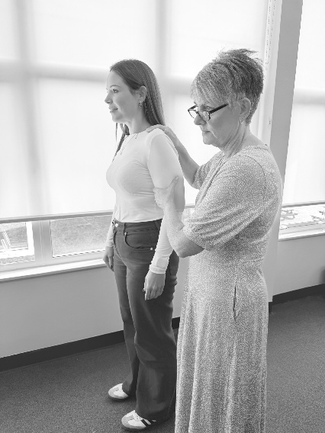 | 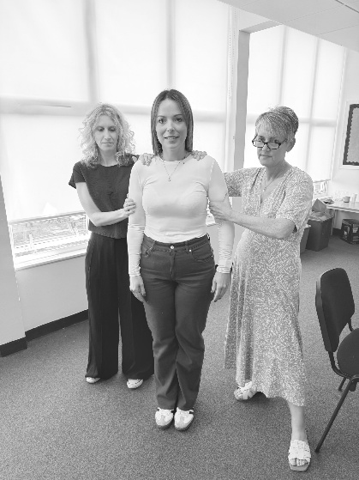
Fist-hold  (2 person) | The practitioner uses their inside hand to form a soft fist over the subject’s fist, if the subject is clenching their own hands or using a tube grip. The practitioner’s outer hand is placed on the subject’s forearm above the elbow. The fist is pulled back towards the practitioner’s body. | 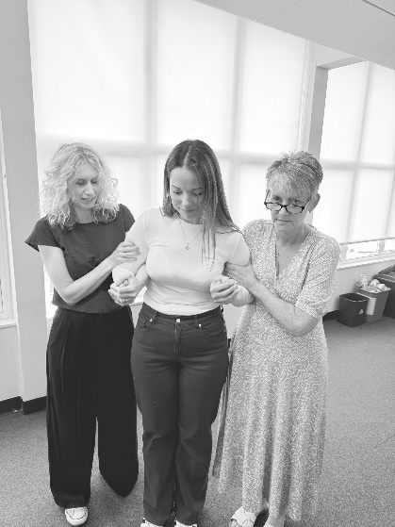 | 
Wrist-hold  (2 person) | The practitioner uses their inside hand to wrap around the narrowest part of the subject’s wrist, while the remaining fingers wrap across the back of the subject’s hand.  The practitioner’s outer hand is placed on the subject’s forearm above the elbow. The arm is pulled back towards the practitioner’s body (not as far as with the fist hold). | 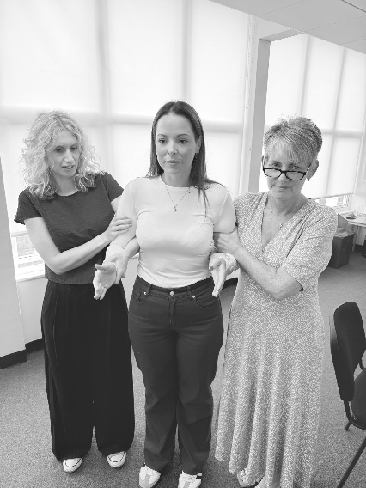 | 
Extended-arm hold  (2 person) | The practitioner uses their inner arm to hold the subject’s arm above the elbow.  The practitioner places their other hand on top of the subject’s wrist, keeping the subject’s arm extended straight and across the practitioner’s body (holding across the body like a seat belt).  The subject’s limb is kept close to the practitioner’s body for leverage, but the arm remains straight rather than bent or locked into a wrist lock. | 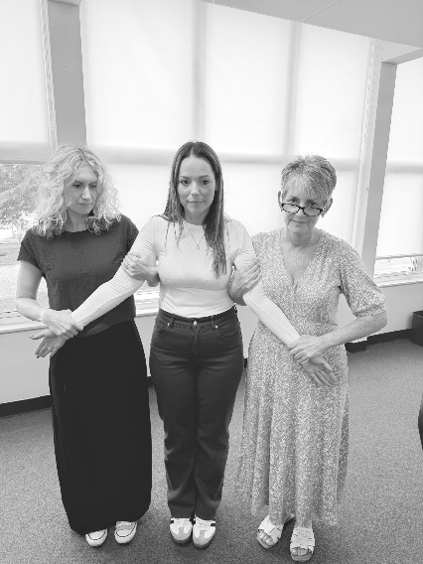
Stabilising the situation in response to a hair grab:
Method 1:  Instruct and/or Tickle | The practitioner tells the subject to ‘Let go.’  The practitioner can use a tickle as a distraction.
Method 2:  Hair Grab - Wrist Hold | The practitioner uses the wrist hold to stabilise the subject’s hand against the victim’s head to stop the pulling force causing further injury. | 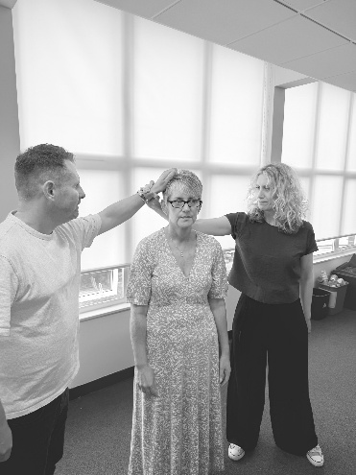 | 

Appendix 2: Record of Use of Restricted Physical Intervention Form

School |  |  |  |  |  | Child’s Name
Date of Incident |  |  | Time of Incident |  |  |  |  | Location of Incident
Duration of Physical Restraint |  |  | Staff directly involved
Other children involved |  |  |  |  |  | Witnesses to incident
Child’s Needs
Does the child have an identified Special Educational Need or Disability (SEND)? |  |  |  | Yes ☐ No ☐ |  |  |  |  | If yes — SEN status code |  |  |  |  | SEN K ☐ SEN E ☐
Relevant needs, circumstances or vulnerabilities of the child
(e.g. medical conditions, sensory needs, communication difficulties, known trauma, EAL, diagnosis):
Identified or potential triggers (if known):
Incident Details
Events Leading to the incident (What was happening for the child before the incident? What seemed to trigger the behaviour? Who else was involved or present?)

Behaviour of the child (What behaviour indicated that the chid was struggling to cope or presented a risk? Give a brief account of the incident)
Response from staff – de-escalation strategies used (Which techniques did you use to de-escalate the situation before physical intervention?)
adjust tone ☐ adjust body language ☐ adjust proximity ☐ listen with empathy ☐
offer choices ☐ offer time to process ☐ redirect attention ☐ change of face ☐
Response from staff – de-escalation strategies used (What was the child’s response)
Reason for the use of reasonable force (what was the specific risk to the welfare of the child or others?)
Remember: Use of reasonable force must be:
1. Necessary – no reasonable alternative was available to prevent harm
2. Proportionate – no more force than was necessary for the least amount of time
3. Reasonable in the circumstances

Equality Act 2010 – considerations taken into account (e.g. protected characteristics, disability related factors, age, size, vulnerability)
Description of the Use of Force
Type of hold or method used (What method or type of hold was applied?)
Escort 1 person ☐ Escort 2 person ☐ Wrist hold ☐ Fist hold ☐ Extended arm hold ☐
Response to hair grab: Method 1- Instruct and/or Tickle ☐ Response to hair grab: Method 2 – wrist hold ☐ Seclusion ☐
Degree of force applied (e.g. minimal, moderate, significant — describe the level of force and any factors that influenced it)
Complications during the use of force (Any complications that arose?)
Conclusion of the Incident
How did the use of force come to an end? (What was the outcome and what immediate help and support did you offer to the pupil?)
Staff signature |  |  |  |  |  |  | Date

Appendix 3: Independent Incident Review

Independent Review
(This section must be completed by a member of staff who was not directly involved in the incident)
Was the pupil injured? |  |  | Yes ☐ No ☐ |  |  |  | If yes, has an accident form been completed? |  |  |  |  | Yes ☐ No ☐
If yes, describe the injuries |  |  |  |  |  |  | Was first aid given? |  |  |  |  | Yes ☐ No ☐
Was a member of staff injured? |  |  | Yes ☐ No ☐ |  |  |  | If yes, has an accident form been completed? |  |  |  |  | Yes ☐ No ☐
If yes, describe the injuries |  |  |  |  |  |  | Was first aid given? |  |  |  |  | Yes ☐ No ☐
Did someone receive medical help? |  |  | Yes ☐ No ☐ |  |  |  | If yes, note why, who called, when, and the outcome.
Were the police involved? |  |  | Yes ☐ No ☐ |  |  | If yes, note why, who called, when, and the outcome.
What post-incident support been offered to the child?  (Facilitated by a staff member not involved in the incident) |  |  |  |  | (e.g. debrief conversation, follow-up discussion, counselling referral, wellbeing check-in, regulation support)
What post-incident support been offered to the staff member(s) involved? |  |  |  |  | (e.g. debrief conversation, follow-up discussion, counselling referral, wellbeing check-in)
Where any other children who witnessed the incident provided with support?
Has the incident been recorded on Arbor? |  | Yes ☐ No ☐ |  |  |  |  |  | Has the incident been recorded in the Bound and Numbered Book? |  |  | Yes ☐ No ☐
Have the following people been told about the use of force?
Headteacher | Yes ☐ No ☐ |  |  | Parent/Carer |  |  |  | Yes ☐ No ☐ | Social Worker (where appropriate) |  |  |  | Yes ☐ No ☐

Appendix 4: Pastoral Support Plan Review
Pastoral Support Plan Review (To be completed following review of the incident against the child's existing plan)
Was this action in line with the child’s Pastoral Support Plan (PSP)? Yes ☐ No ☐
If no, please explain: ___

Does the Pastoral Support Plan need to be updated? Yes ☐ No ☐
If yes, please explain what changes are needed: ___

Is a formal review of the plan required? Yes ☐ No ☐
If yes — has a review date been scheduled? Yes ☐ No ☐ Date: _

Pupil Voice: Child's account of the incident
(Where appropriate and possible, record the pupil's perspective of what happened, how they experienced the situation, how they felt at the time, and any views they have about what might have helped. Information may be recorded directly below or through alternative approaches that best support the pupil to communicate their views and experiences.)

Appendix 5: Letter to Parents following Restricted Physical Intervention Incident

Private and Confidential
Date:
Dear Parent/Carer,
I am writing to inform you that a physical intervention was used with your child, [Child's Name], on [Date, Time and Location of Incident].
The intervention was necessary to ensure the safety and wellbeing of your child, other pupils and/or staff, and was carried out in accordance with the school's Behaviour Policy and Physical Intervention Procedures.
Reason for Intervention
A physical intervention was necessary in order to
Delete as applicable:
prevent injury to the pupil
prevent injury to others
prevent serious damage to property
prevent significant disruption
prevent the pupil leaving an area where their safety was at risk
The type of physical intervention used was
Delete as applicable
a Single Person Escort
a Two Person Escort
a Fist Hold
a Wrist Hold
an Extended Arm Hold
a safe released to the floor
The approximate duration of the physical intervention was…
Delete as applicable
Your child was uninjured / sustained the following injuries…
No medical treatment was required / first aid was administered by / further medical assessment is required due to…
The following support was provided after the incident
Delete as applicable
debrief with pupil
emotional regulation support
restorative conversation
SEN/Pastoral team involvement
The incident has been reviewed and recorded in line with trust procedures.
Delete as applicable
We will continue to monitor and support your child to reduce the likelihood of similar incidents occurring in the future
We would like to arrange to meet with you to review Pastoral Support Plan /Risk Assessment.
Should you wish to discuss this matter further, please contact Head teacher Kelvin Chappell.
Yours sincerely,

Parent/Carer Acknowledgement (Optional)
I acknowledge receipt of this notification regarding the physical intervention involving my child.
Parent/Carer Name: ______________________________
Signature: _____________________________________
Date: _________________________________________

