Chestnut Class learning Thursday 25th June 2026
English | Plan a ‘best birthday ever’ day. What would you choose to do? What would you have to eat?  Imagine that you could invite ANY 5 people (or characters) of your choice – Harry Styles? Taylor Swift? Harry Potter? The Gruffalo? Mo Salah?  Task 1: Write a list/timetable/schedule of the day.  Task 2: Write a persuasive letter to your number 1 guest, begging them to come to your party.
Time to talk | Jack and the Beanstalk: Would you rather face a giant in the clouds or a dragon in a cave?  Hansel and Gretel: Would you rather live in a house made of sweets or a house made of Lego?  Cinderella: Would you rather have a fairy godmother for one day or a magic flying carpet forever?  The Three Little Pigs: Would you rather build a house out of straw, wood, or brick if you had to do it yourself?
Maths – The Mystery of the Missing Glue Sticks (a separate download).
Art and Design activities
 |  | Design a fantasy water park – complete with an aquarium perhaps? You can make it out of construction/Lego if you choose.
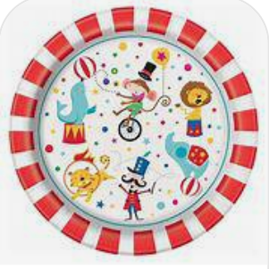 |  | Work on your Campfest artwork by designing circus themed pictures on your paper plates.

