Thursday 25th June Year One- Home Learning.
Activity 1- Phonics.
Complete the ai/ ay sheet.
Activity 2- Maths
Complete the maths sheet.
Activity 3- Literacy
Describe the tiger on attached sheet

Activity 4 Art Natural Collage.

Look at the images below of art made from natural resources.
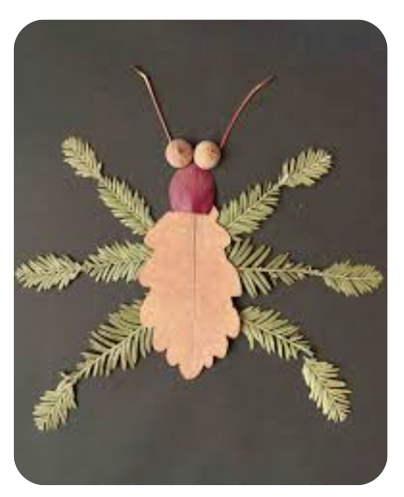
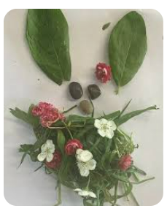
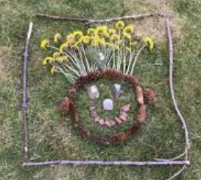
Collect some natural materials and create your own natural collage. You can make a picture of anything you like; you, a mini-beast, a super hero, your family or a favourite toy!
Tell an adult about your masterpiece and why you have chosen the different materials to represent each part. I would love to see some photos of your art.

