Thursday 25th June Reception- Home Learning.
Activity 1- Phonics.
Go through your phonics home learning sheet with an adult. This should be in your phonics folder or book bag.
Spelling Common Exception Words
- Choose a common exception word and look at it, try to take a picture of the letters with your brain.
- Cover the word and write it.
- Uncover the word and check how you got on, fix any mistakes.
- Repeat with the same word or different words.
Challenge- can you write a sentence including a common exception word? You could think of your own sentence or write one of the sentences from your phonics home learning sheet, remember don’t copy the sentence instead sound out each word and write the common exception word from memory

Activity 2- Maths
Counting, Counting, Counting
Today I want you to practice reciting numbers to 20 and then counting some larger groups of objects.
- With an adult recite number to 20, can you go higher?
- Next practice counting down from 20 to 0.
- With an adult take it in turns to say a number and count to 20- e.g child says 0, adult says 1, child say 2, adult says 3 etc

Activity 3- Reading
Ask an adult to read you a story book of your choice.
Draw or write your favourite part of the story on the attached book review sheet.
Tell an adult why that was your favourite part of the story- how did it make you feel?
Activity 4 Art Natural Collage.
Look at the images below of art made from natural resources.
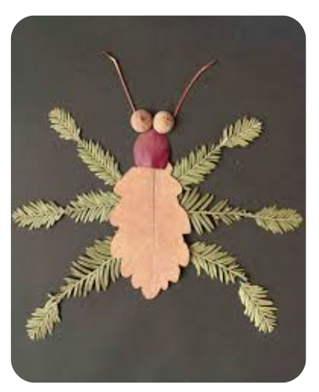
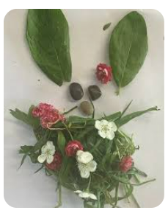
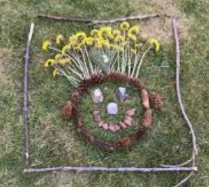
Collect some natural materials and create your own natural collage. You can make a picture of anything you like; you, a mini-beast, a super hero, your family or a favourite toy!
Tell an adult about your masterpiece and why you have chosen the different materials to represent each part. I would love to see some photos of your art.

