Beech Class learning Wednesday 24th June 2026
English | Use this story starter to EITHER write your own story OR create a comic strip.  🍿 The Great Popcorn Plot  Every single bag of popcorn sold at the midnight show had turned a bizarre, bright shade of purple, and anyone who ate it instantly lost the ability to speak. Mack, the acrobat's son, watched in horror as the audience could only communicate through frantic hand gestures and wild pointing. Clutched in the hand of the sleeping popcorn vendor was a tiny brass key shaped like a clown's shoe, which didn't fit any lock Mack had ever seen before …
Time to talk | Would you rather – slide down rainbows or bounce on clouds?  Did Humpty Dumpty fall or was he pushed?  Should a theme park be built on Box Rec? Discuss the arguments for and against.
Maths – melted ice cream mystery
(a separate attachment)
Art and Design activities
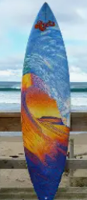 |  | Design your own surfboard!
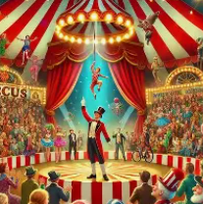 |  | Create a map of the most amazing circus on Earth!
 |  | Design a menu for lunch or tea and help to prepare it.

