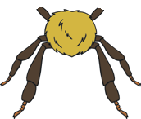
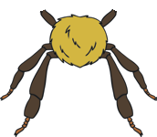


Can You Sort the Minibeasts?
Legs
No Legs
twinkl.com

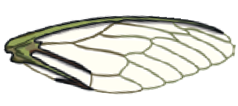
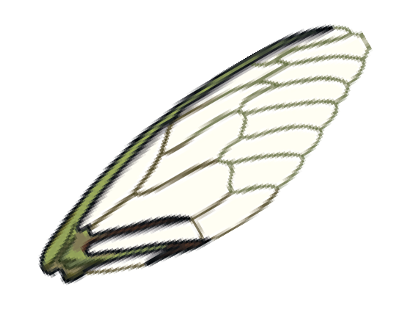
Can You Sort the Minibeasts?
Wings
No Wings
twinkl.com

How Will You Sort the Minibeasts?
twinkl.com

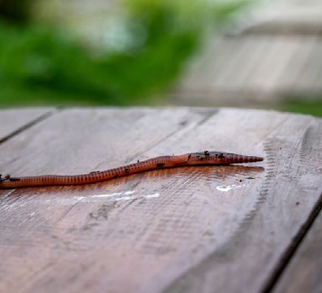
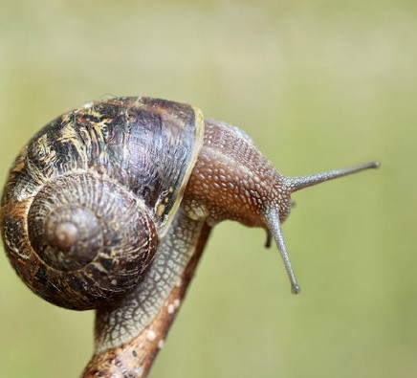
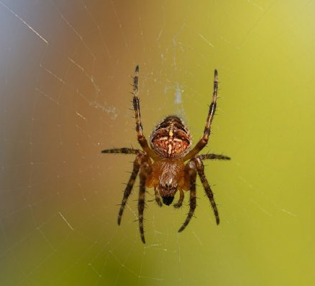
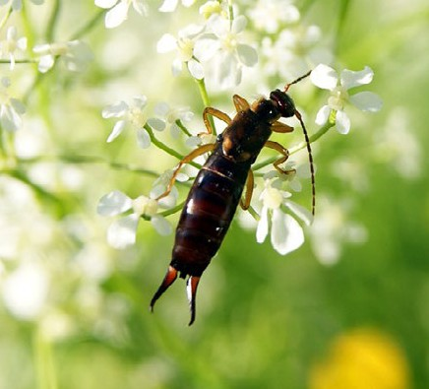
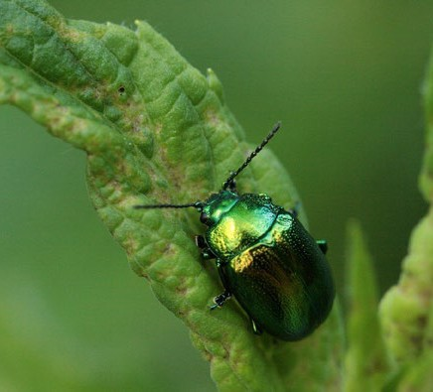
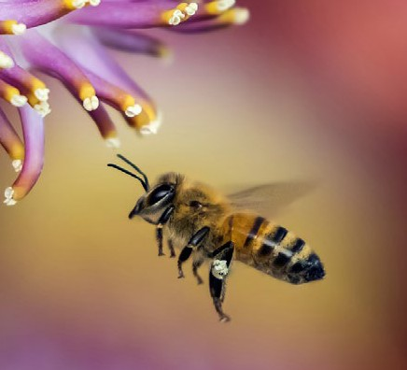
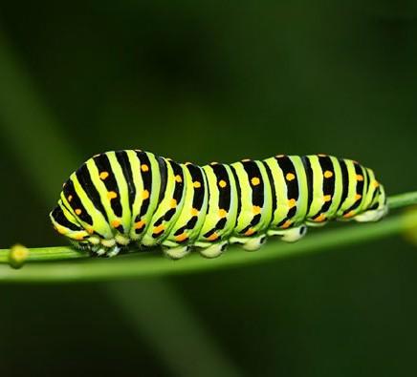
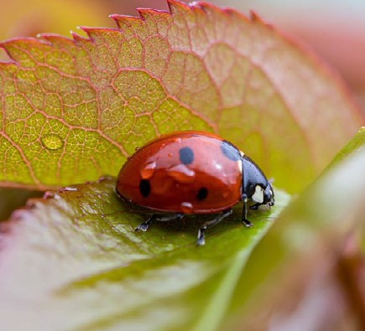
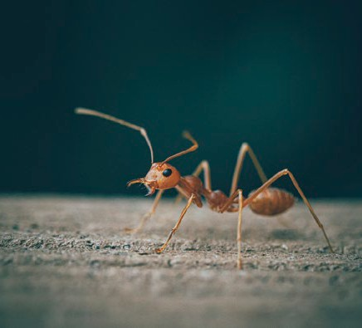
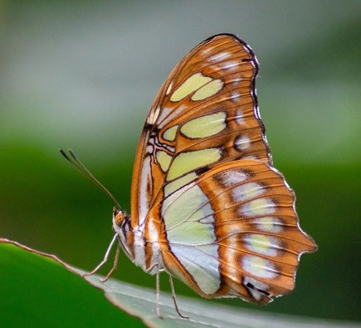
This resource is editable and can be adapted to meet the needs of different children. Twinkl cannot be held responsible for any changes made once a resource has been downloaded.
Please be aware that this content may have been edited and therefore may no longer reflect our values.

twinkl.com

twinkl.com

twinkl.com

twinkl.com

twinkl.com

twinkl.com

twinkl.com

twinkl.com

twinkl.com

twinkl.com

