Home Learning 24th and 25th June
English
Please write a story.

This is the first line of your story. What happens next is up to you.
Think about: what is it? Why is she there? What does she want?
If you need some more prompts to get started, then please look below. There is also a prompt sheet attached which includes some ideas including fronted adverbials, subordination and wider punctuation.
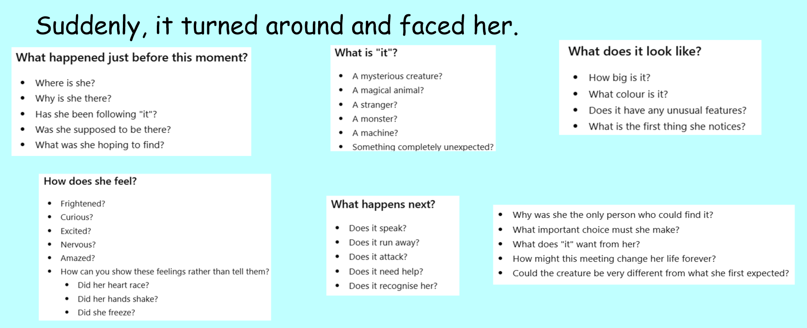
Maths
Have a go at the maths investigation. The answers are also attached for you to check when you are finished. There is also an extension if you finish quickly.
Spelling
Practise your spelling words. You could use bubble writing, backwards, then forwards, wiggly writing or put them into silly sentences.
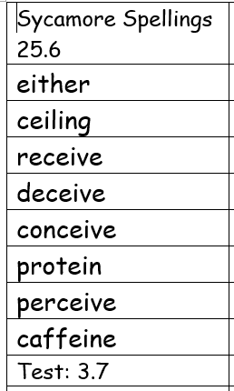

Art
Design and create a front cover for your story. Make sure it includes the title, the author and a picture of some kind.

