Chestnut Class term 6 spelling lists

Chestnut spellings T6 WK3  Test on Friday 19.06.26 | Chestnut spellings T6 WK3  Test on Friday 19.06.26 | Chestnut spellings T6 WK3  Test on Friday 19.06.26
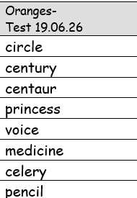 | 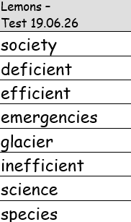 | 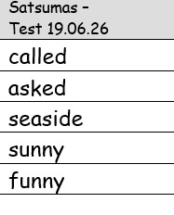
Chestnut spellings T6 WK4  Test on Friday 26.06.26 | Chestnut spellings T6 WK4  Test on Friday 26.06.26 | Chestnut spellings T6 WK4  Test on Friday 26.06.26
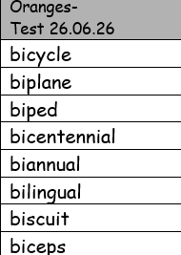 | 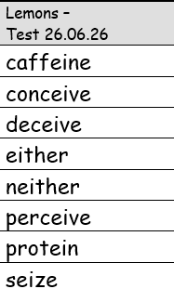 | 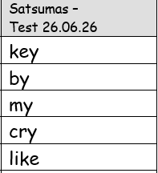
Chestnut spellings T6 WK5  Test on Friday 03.07.26 | Chestnut spellings T6 WK5  Test on Friday 03.07.26 | Chestnut spellings T6 WK5  Test on Friday 03.07.26
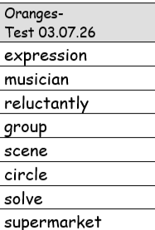 | 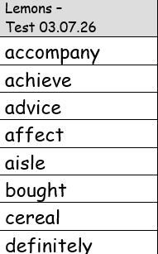 | 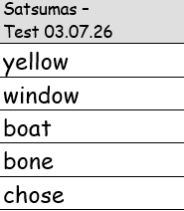
Chestnut spellings T6 WK6  Test on Friday 10.07.26 | Chestnut spellings T6 WK6  Test on Friday 10.07.26 | Chestnut spellings T6 WK6  Test on Friday 10.07.26
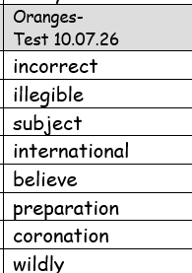 | 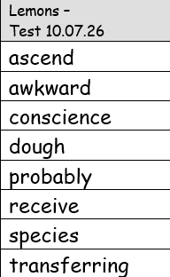 | 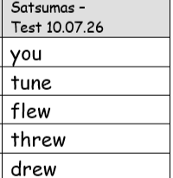
Chestnut spellings T6 WK7  Test on Friday 17.07.26 | Chestnut spellings T6 WK7  Test on Friday 17.07.26 | Chestnut spellings T6 WK7  Test on Friday 17.07.26
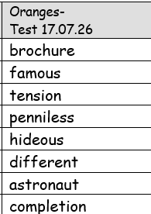 | 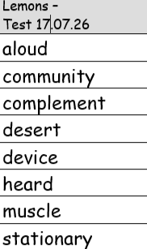 | 

