In 1926, George Jardine Kidston donated Mead Fields to Box Parish Council to form the Recreation Ground, known as Box Rec. From that point onwards, Box Rec has been the place for the people of Box to meet friends, spend time with their family, play sport, attend events, walk their dog, play in the park and generally have fun!

We are putting together an exhibition that showcases 100 years of memories, and we would like you to send in your favourite memory of Box Rec. This could be a photo or a drawing with a few sentences explaining your memory. You might want to use the sentence starters – I remember, My favourite place, I like to. Please hand in your memory to your teacher by Friday 8th May.

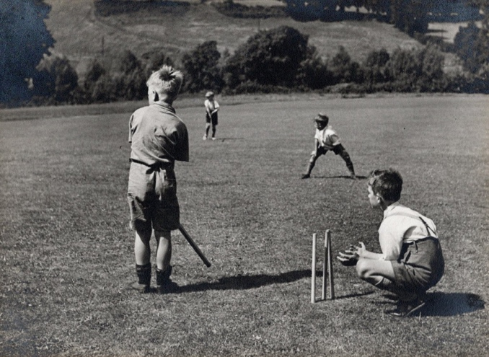
These memories will join the exhibition at Box Revels Fete Day on Monday 25 May and then it will be in Box Library throughout the summer. Please do come along to either and see all the amazing memories we have collected. The very best bits of the exhibition will go in a time capsule to be buried on Box Rec and dug up in 100 years’ time!

Permission to use photos – by sending in a photo you are agreeing to its use in the exhibition. If it has other children in it, please ensure you have their parents’ permission for us to use it too.

Other birthday activities

In the next few weeks boards showcasing some of the memories we have already collected will be going up around the village. Keep your eye for them, there will be 9 in total.

Box Parish Council have written a quiz about Box Rec. Everyone who completes the quiz gets a sweet and entered into a prize draw to win a £25 book token.

