Chestnut home learning 16th April 2026 (Please hand in by 21st April)
Please CHOOSE one or two of the challenges below and put your sketches or photos in your home learning book. Be sure to spend 30 – 45 minutes of quality learning time on this.
Task Title | Description
Build a Mini Truss Bridge Challenge | Build a 30 cm truss bridge using household materials and test its strength. | 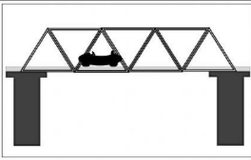
Research the World’s Most Impressive Bridges | Choose three famous bridges and create a fact file. | 
Design a Fantasy Bridge for a Story Character | Draw and label a creative bridge suited to a fairy-tale character. | 
Truss Detective: Spot the Triangles | Find and sketch or photograph five real-life structures using triangles. | 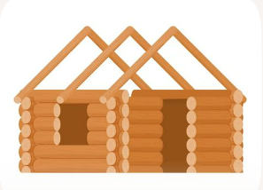
Bridge Designer’s Sketchbook | Sketch three different truss bridge designs for different purposes. | 

