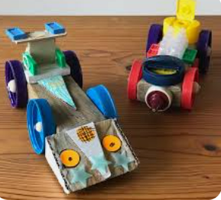
Home Learning Oak Class Friday 13th February
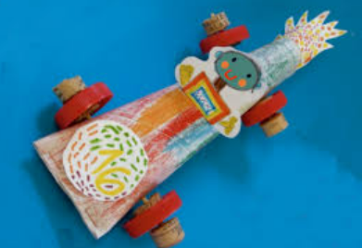
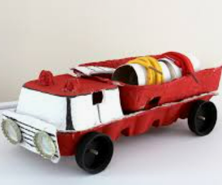
For home learning this week would you design and make a wheeled vehicle to bring back to school after the half term holiday. You can make it out of things like card or recycling materials. Or choose something like lego. Draw your design below and make it to bring in and share with the class. Or you can send in photos if you’d prefer.

Please hand it in on Wednesday 25th February

