Key Stage Two Home Learning – Friday 23rd January 2026
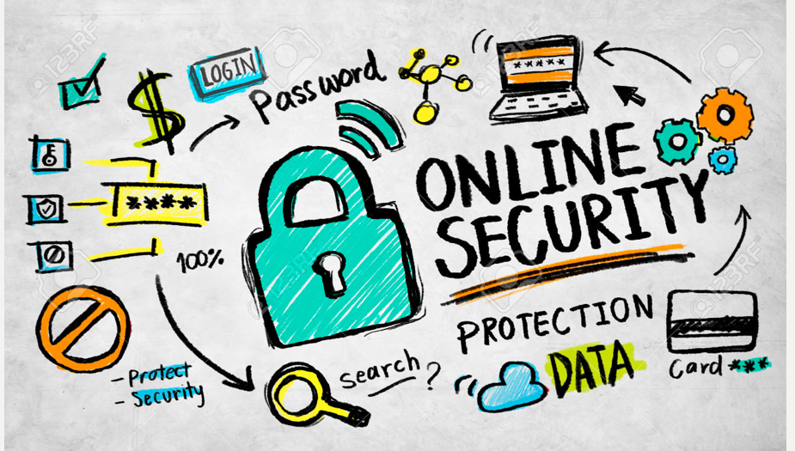
This week, the children were visited by Wiltshire Police to learn about how to keep themselves safe whilst online. Home learning is to share with your parents/carers what you have learned and have a discussion together about the key points. The powerpoint for you to discuss is on our homework page on the school website.
Please hand this in by Wednesday 28th January.
What does ‘rock’ stand for?

What does a ‘safe’ online profile look like?

What should you do if you think that someone might be being ‘cyber-bullied’?

What did you and your adults chat longest about?

Parent signature ___________________________

