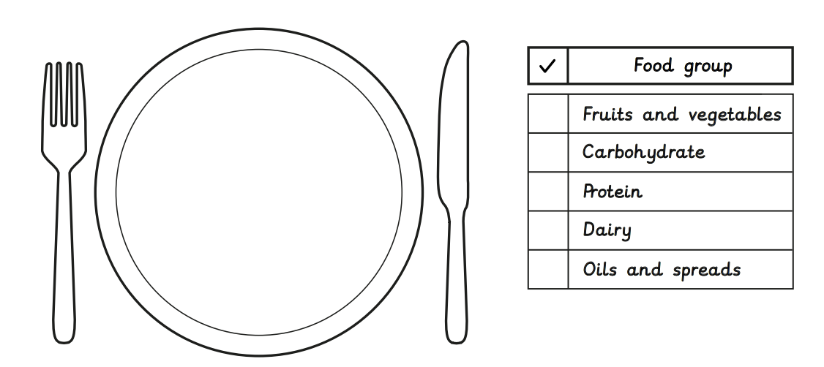
My evaluation of my meal:

_________________________________________________________________________________________________________

