Home Learning Oak Class- Friday 28th November
For home learning this week please can you design a balanced plate of food for a meal and then make it and eat it. Take a photo of it and say what you thought of it.
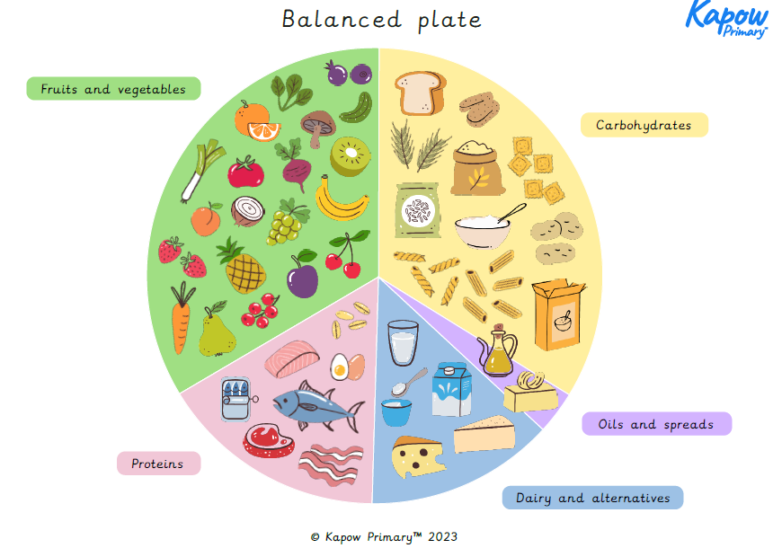

*Please can children who have words for the Nativity practice them so that they can now do them without a script.

Homework due on Wednesday 3rd December for marking

