Sycamore Class Homework due in Wednesday 12th November
Below are two extracts and some inference questions about them. Each questions walks you through how to form a complete answer using evidence from the text. Aim to spend about 40 minutes on this, this may mean answering all of the questions or just the first set.
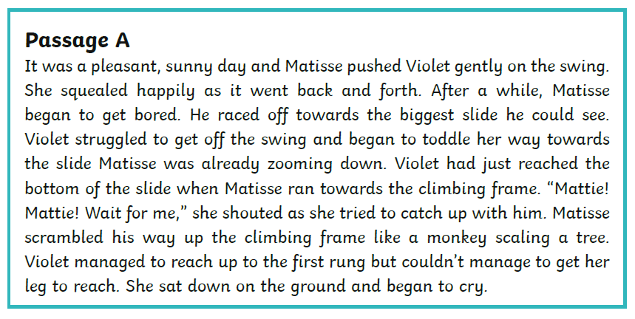
Where are Violet and Matisse?______________________________
What clues are there in the text that makes you think this? _________________________________________________________________________________________________________________________________________________________________________________
Now put both parts of your answer together to form a full answer using evidence from the text.
____________________________________________________________________________________________________________________________________________________________________________________________________________________________________________
Who do you think is older, Violet or Matisse? _________________
What clues are there in the text that makes you think this? _________________________________________________________________________________________________________________________________________________________________________________ Now put both parts of your answer together to form a full answer using evidence from the text.
____________________________________________________________________________________________________________________________________________________________________________________________________________________________________________
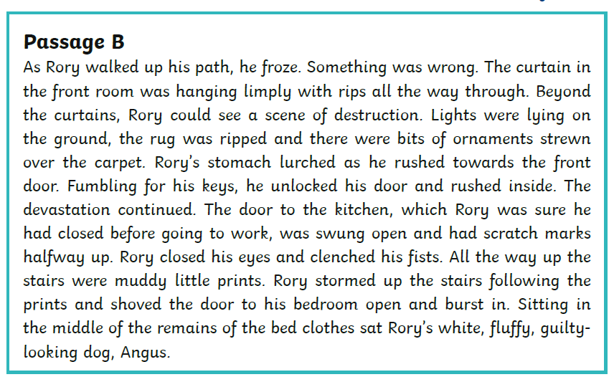
Who or what has caused the destruction in the house? ________________
What clues are there in the text that makes you think this? _________________________________________________________________________________________________________________________________________________________________________________
Now put both parts of your answer together to form a full answer using evidence from the text.
____________________________________________________________________________________________________________________________________________________________________________________________________________________________________________
How does Rory feel? _____________________
What clues are there in the text that makes you think this? _________________________________________________________________________________________________________________________________________________________________________________
Now put both parts of your answer together to form a full answer using evidence from the text.
____________________________________________________________________________________________________________________________________________________________________________________________________________________________________________

