Oak Class Home Learning – Friday 7th November
Write a postcard to recount your weekend.
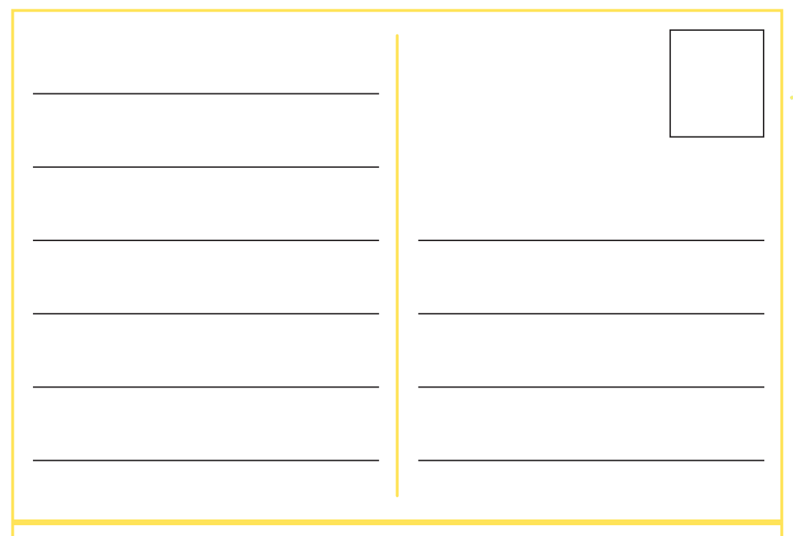





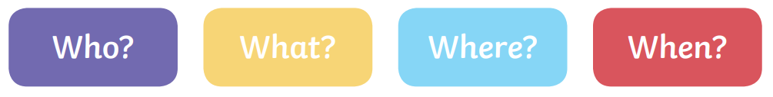
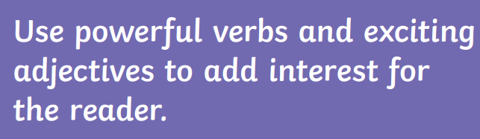

Please hand it in on Wednesday 12th November to be marked.

