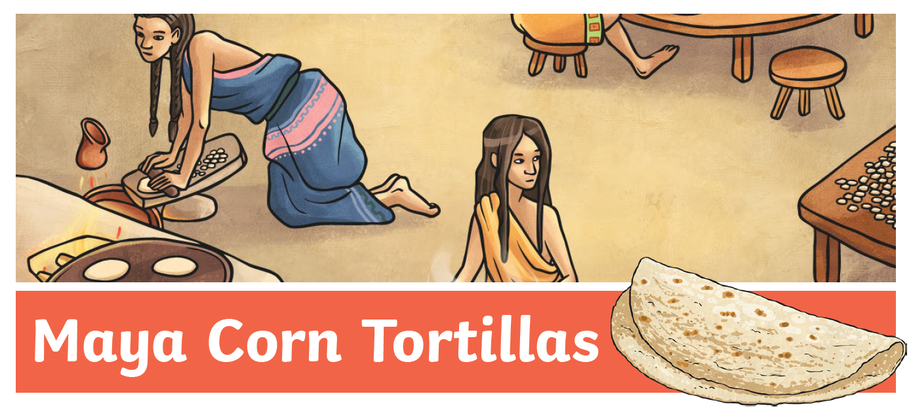
Ingredients
- 200g flour
- 100ml water
- 2tbsp oil

Method
- Mix all of the ingredients in a bowl together and mix to form a workable dough. If it’s too sticky add a little flour, if it’s too dry add more water.
- Divide the dough into small balls.
- Flatten the balls between your hands, or use a rolling pin, to an approximate depth of 3mm.
- Cook the tortillas in a lightly oiled frying pan for approximately 1 minute each side over a high heat.

