Maths Home Learning – Friday 3rd October
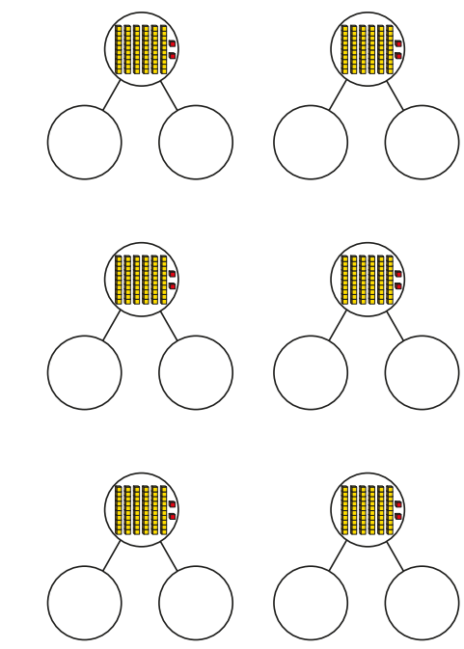
Practice flexibly partitioning two-digit numbers. Parents: ‘Partitioning’ a number means splitting it up into the values of its digits. 37 = 30 + 7; 20 + 17…
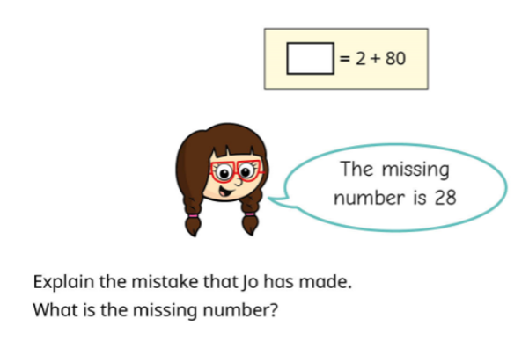
Complete the problem. Please write your answer in a full sentence using the word because to explain why.
Do you agree or disagree with Jo?
Explain why.
________________________________________________________

________________________________________________________

________________________________________________________

