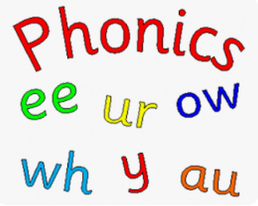
Y1 Oak Class Home Learning – Friday 26th September
For home learning this week, I would like you to
practice your phonics to read and spell words. I’d
also like you to practice your spelling of tricky
words, otherwise know as common exception
words.

Practice saying the sound when pointing at the sound. Then get mum or dad to say the sound and you point at it.
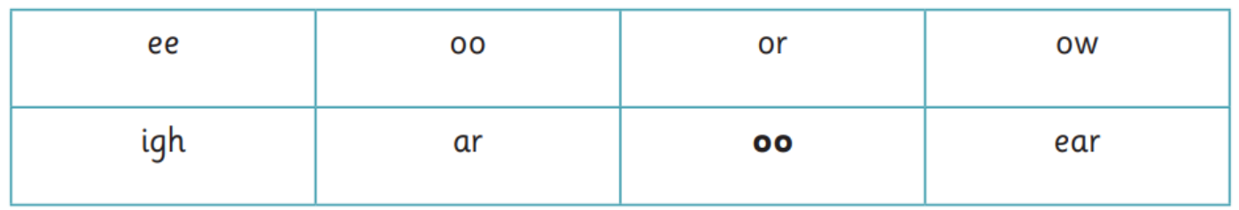

Now practice reading and spelling these words.


