Science
As this week is science week, here are some options for science homework this week. We explored adaptions and changes in animals and the environment.
Option 1: Practical science exploring changes in the environment. Take pictures and send them to Miss Reed/Mrs Ashton to share next week.
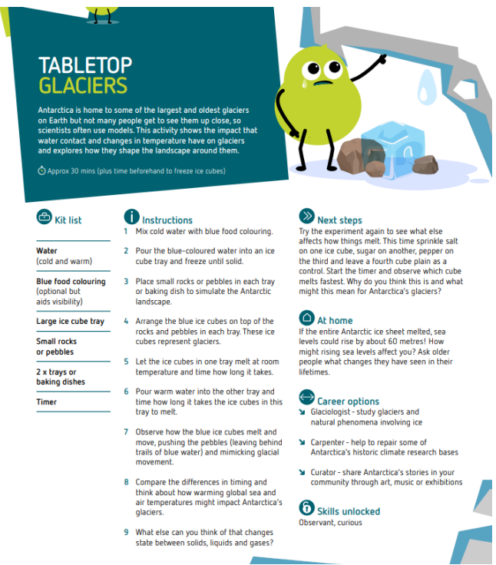

Option 2:
Adaptations in Animals
Research an animal of your choice and explain how they have adapted to their environment. Present this however you would like e.g a poster or powerpoint
Adaptations could be:
1. Behavioural e.g. they migrate, are nocturnal, huddle in a group
2. Physical e.g. they are camouflaged, have big ears, large claws, blubber layer
3. Life cycle e.g. they change as they grow such as the butterfly or frog

Be prepared to share this next week

