Homework due in Wednesday 26th February
This term we have been reading Impossible Creatures by Katherine Rundell. For your holiday homework, I would like you to create your own Guardian’s Bestiary. Create some impossible creatures of you own- create images of them (either by drawing or using technology) and then write a description of them and their characteristics.
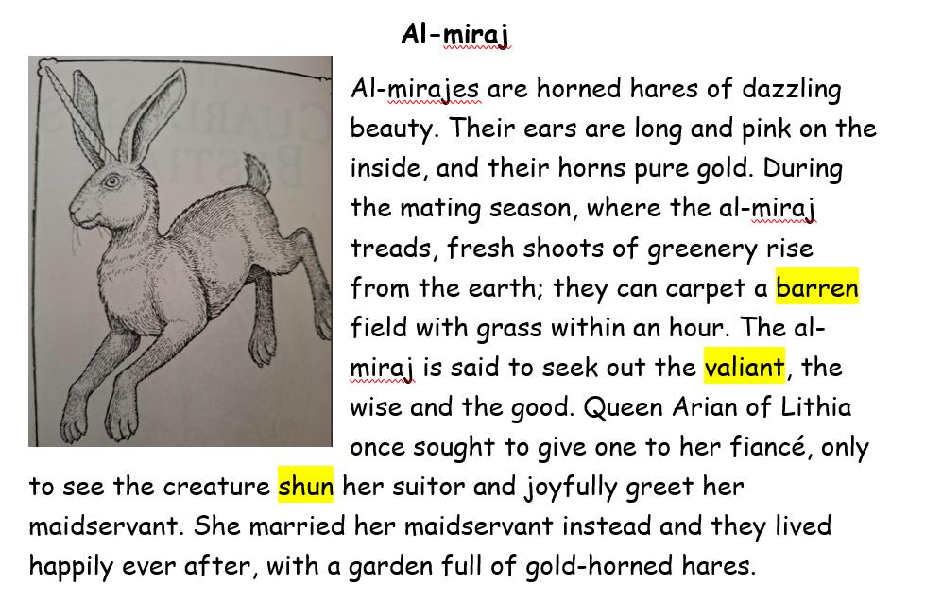
Here are a few examples of ones that we’ve read to start you off.



