
Christmas Homework

Homework Task – Over the Christmas holidays make sure that you continue reading and completing your reading diaries. Spend some time on TT Rock Stars and spelling shed- if you need your codes let me know. As an extra challenge you could try to complete the Christmas scavenger hunt. You can use your pages in your homework book to complete the tasks but most importantly of all, relax, have fun and enjoy Christmas!

  Watch a Christmas film  20 Points |   Sing a Christmas song  20 Points |   Have a hot chocolate  10 Points |   Go to the park  25 Points

  Write an acrostic poem for the word Christmas  30 Points | 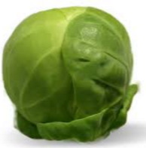  Eat a Brussel sprout  25 Points | 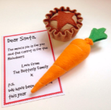  Leave presents out for Santa – Mince pie / Carrot  10 Points |   Play with a friend  20 Points
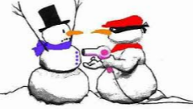  Tell a Christmas joke  10 Points |   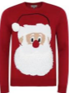  Go for a walk wearing a Christmas jumper or hat  40 Points |   Wish someone a ‘Merry Christmas’  30 Points |   Write a Christmas story including Santa and Rudolph  50 Points
  Draw a Christmas picture  30 Points | 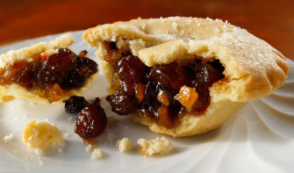  Eat a mince pie  15 Points | 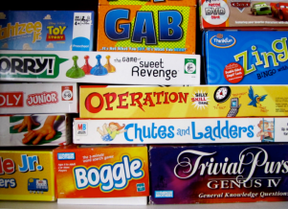  Play a board game  20 Points | Total Points Scored

