MATHS - YEAR 5
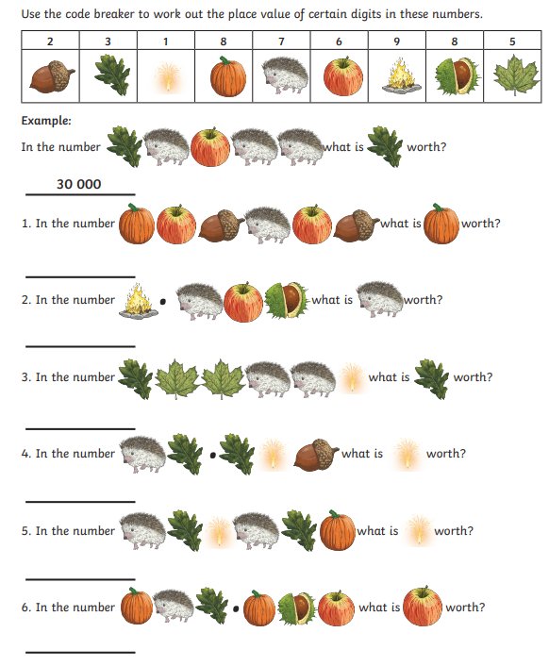

Now write three of your own questions using this code. It could be an addition, subtraction, multiplication or division question. Make sure you also solve it!

