Maths Home Learning – Friday 22nd November

Fill in the missing numbers.
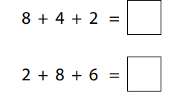
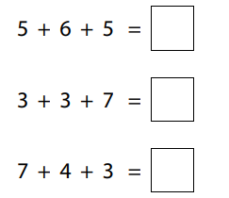
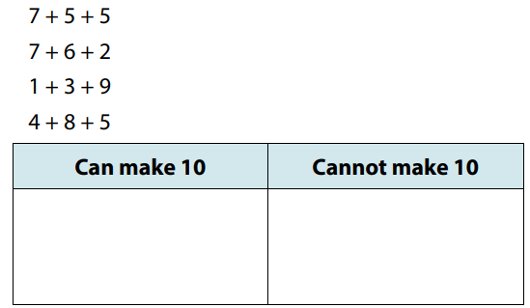
Sort the expressions.

Fill in the missing squares, using the digits below so that each row and column adds up to the same number.
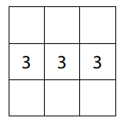
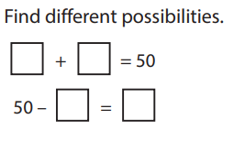
0 1 2 4 5 6









