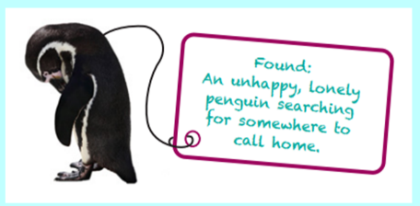
Oak Class Home Learning
Make and write a label for a toy - 8th November 2024:
This week we found a lost penguin in Oak class called Pip. Around it’s neck was a label which read:
Found:
An unhappy, lonely penguin searching for somewhere
to call home.
For home learning this week, I would like to choose a toy animal you have that might be lost and wanting to find its way home. Write your own label for it and use a list sentence, choosing 2 or 3 adjectives to describe it. Here’s a word bank to help you or you can choose your own adjectives.
sad | unhappy | downhearted | miserable | dejected
lonely | abandoned | isolated | outcast | rejected

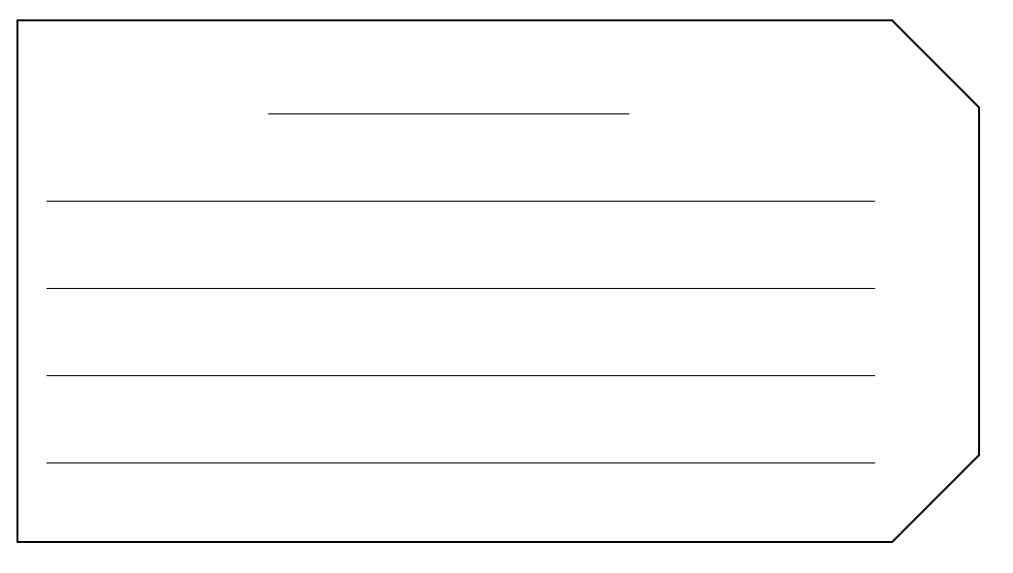
You can also, if you would like to, make your label and tie it around your toy animal to bring into school to show.

Please hand it in on Wednesday 13th November to be marked.

