Maths Home Learning – Thursday 17th October
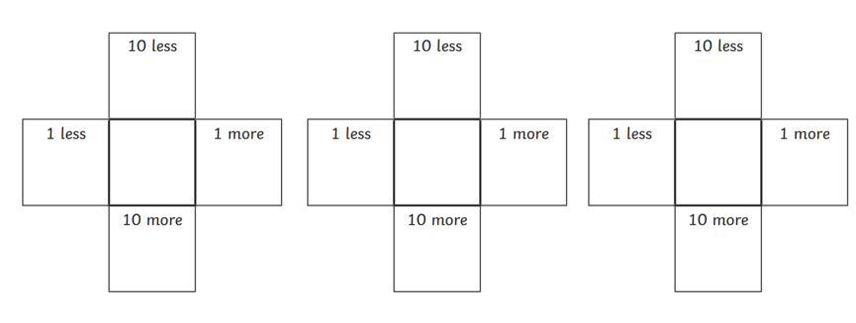
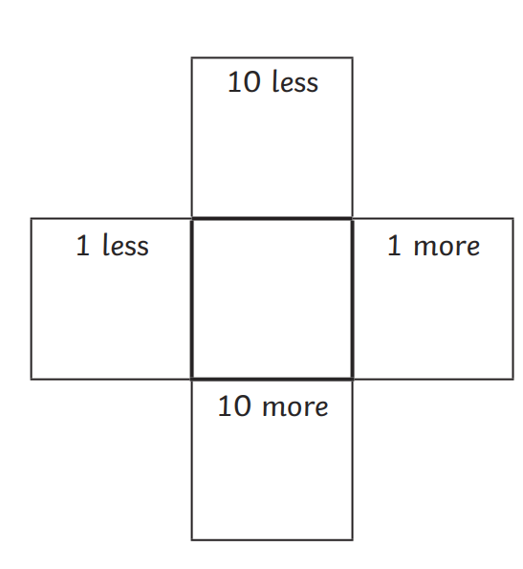
Choose a 2-digit number on the hundred square and colour it in. Write it in the middle square then use your hundred square to find 10 more and less; 1 more and less. Colour the numbers on your 100 square.
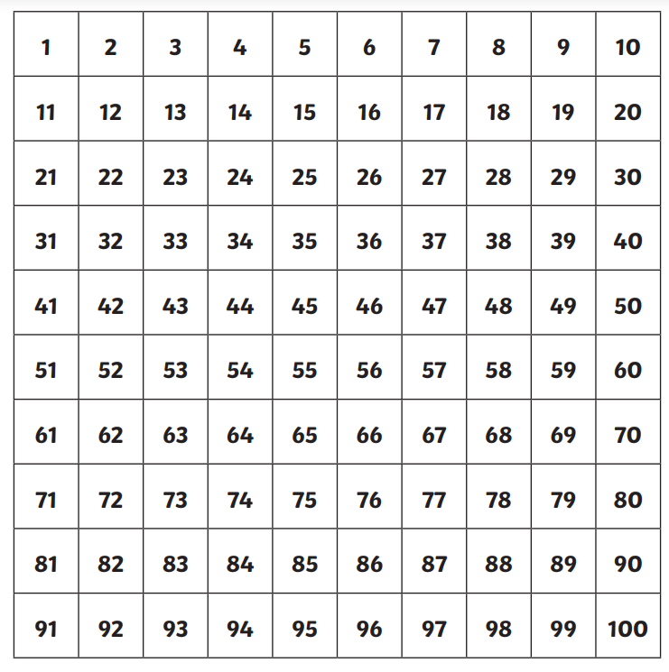

Numbots
Numbots really helps develop children’s fluency with number and therefore confidence when doing more difficult maths. Doing a little often works. In your child’s home learning book I have stuck their username and password for Numbots. Numbots recommend that children spend 3 minutes four times a week on it. I have set this time as a minimum for children. Please can you encourage them to get into the habit of doing this, deciding which days and when they will do it. If you have any trouble getting on to it, just let me know.

Numbots
Numbots really helps develop children’s fluency with number and therefore confidence when doing more difficult maths. Doing a little often works. In your child’s home learning book I have stuck their username and password for Numbots. Numbots recommend that children spend 3 minutes four times a week on it. I have set this time as a minimum for children. Please can you encourage them to get into the habit of doing this, deciding which days and when they will do it. If you have any trouble getting on to it, just let me know.

Numbots
Numbots really helps develop children’s fluency with number and therefore confidence when doing more difficult maths. Doing a little often works. In your child’s home learning book I have stuck their username and password for Numbots. Numbots recommend that children spend 3 minutes four times a week on it. I have set this time as a minimum for children. Please can you encourage them to get into the habit of doing this, deciding which days and when they will do it. If you have any trouble getting on to it, just let me know.

