Y1 Maths Home Learning – Thursday 3rd October
Comparing numbers to 10. Write < > or = on the line.
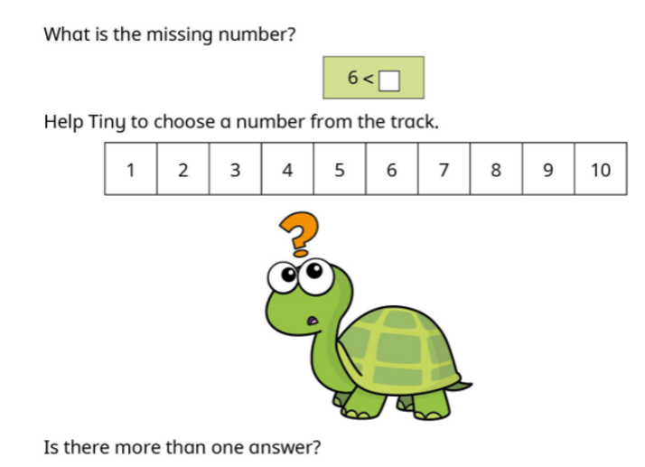
Then answer this question.

