Homework set- Friday 27th September
Homework due in – Wednesday 2nd October
Year 5 have been learning about addition and subtraction with numbers up to one hundred thousand. For your homework I would like you to spend time practising. There are 3 different challenges, start at challenge 1 and work your way through. Aim to spend about 30 minutes on this, getting up to whichever challenge you do in this time. Record the answers in your homework book.
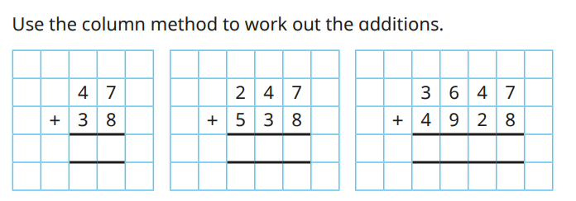
Challenge 1-

And the subtractions.
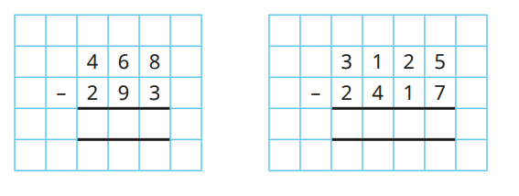

Challenge 2-
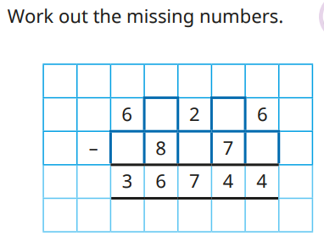
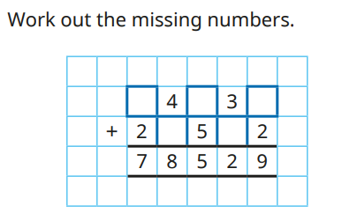
Challenge 3-


