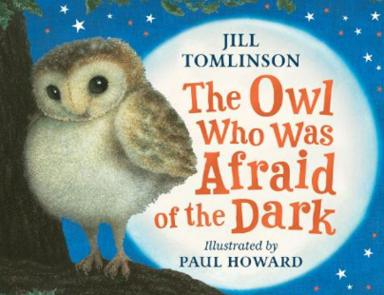
Oak Class Home Learning
The Owl who was Afraid of the Dark- 27th September 2024:
Our class story this term is The Owl who was Afraid of the Dark by Jill Tomlinson. The main character, who is an owl – Plop, is afraid of the dark which is a bit difficult when you’re an owl! For your home learning this week please can you find out about Barn Owls. Draw a picture and label it and draw and write a few facts that you have found out. For example: What do they like to eat? How do they fly so quietly? What’s special about owls?
_______________________________

_______________________________

_______________________________

_______________________________

_______________________________

_______________________________

________________________________________________________________

________________________________________________________________

________________________________________________________________

________________________________________________________________

Please hand it in on Wednesday 2nd October to be marked.

