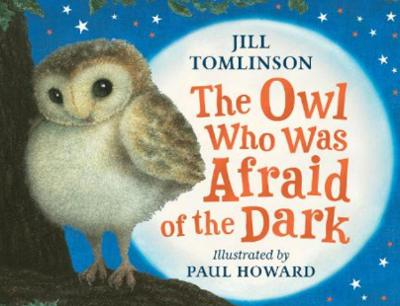
Oak Class Home Learning
The Owl who was Afraid of the Dark- 27th September 2024:
Our class story this term is The Owl who was Afraid of the Dark by Jill Tomlinson. The main character, who is an owl, Plop is afraid of the dark which is a bit difficult when you’re an owl! For your home learning this week please can you find out about Barn Owls. Draw a picture and label it and draw and write a few facts that you have found out. For example: What do they like to eat? How do they fly so quietly? What’s special about owls?

________________________________________________________________

________________________________________________________________

_______________________________________________________________

_______________________________________________________________

Please hand it in on Wednesday 2nd October to be marked.

