Maths Home Learning – Thursday 19th September
Practice counting in tens and ones using the base 10 and place value chart. Then complete the problem. Please write your answer in a full sentence using the word because to explain why.

Do you agree or disagree with the statement?
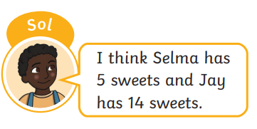
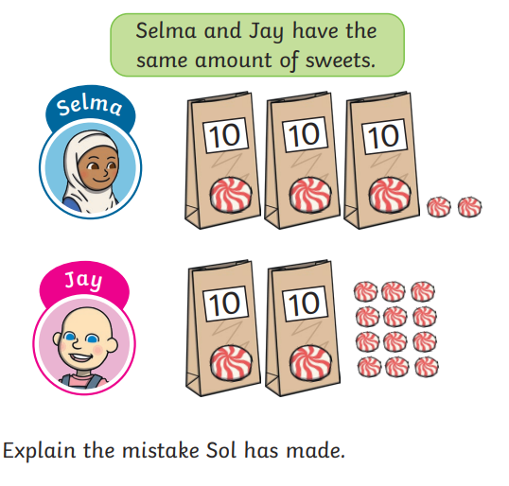
Explain why.

________________________________________________________

________________________________________________________

________________________________________________________

