Willow Class Homework- Campfest; Date; 28/6/24
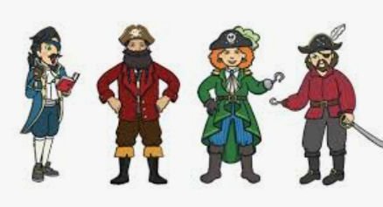
Campfest will soon be upon us and the children are all busy practising their class songs and perfecting their performances! Willow class’ theme is ‘Pirates’ and we are learning two songs to perform. As homework, please could you encourage your child to practise the words to both songs that are on the sheet in their homework books.
We will be dressing up as pirates for our performance so the children may be asking about pirate costumes. This can be as simple or as elaborate as you like! Please do not feel that you need to go out and buy anything; a simple stripy t-shirt, rolled up pair of jeans and bandana will be fine!
Any pirate props such as cutlasses (safe), parrots (toy) and treasure/chests (not valuable) will be more than welcome!
Thank you for your support,
Tamsin Iacono

When I was one I played the drum The day I went to sea. I jumped aboard a pirate ship And the captain said to me… We’re going this way, that way Forwards and backwards Over the Irish Sea A bottle of rum to fill my tum And that's the life for me
When I was two I buckled my shoe The day I went to sea. I jumped aboard a pirate ship And the captain said to me… We’re going this way, that way Forwards and backwards Over the Irish Sea A bottle of rum to fill my tum And that's the life for me
When I was three I grazed my knee The day I went to sea. I jumped aboard a pirate ship And the captain said to me… We’re going this way, that way Forwards and backwards Over the Irish Sea A bottle of rum to fill my tum. And that's the life for me
When I was four I knocked on the door The day I went to sea. I jumped aboard a pirate ship And the captain said to me… We’re going this way, that way Forwards and backwards Over the Irish Sea A bottle of rum to fill my tum And that's the life for me
When I was five I learnt to dive The day I went to sea. I jumped aboard a pirate ship And the captain said to me… We’re going this way, that way Forwards and backwards Over the Irish Sea A bottle of rum to fill my tum And that's the life for me
The pirate ship is coming,
We know it’s on its way,
The pirate ship is coming,
We’ve seen it in the bay.
A skull and crossbones on the mast,
A wild and noisy crew:
The pirate ship is coming
And it's after me and you!
Yo-ho-ho and a bottle of rum, pirates like to have their fun!
Yo-ho-ho on the ‘Salty Breeze’ as they sail the seven seas.
The captain wears an eye-patch,
A cutlass in his hand,
And on the bridge beside him,
His faithful pirates stand.
A skull and crossbones on the mast,
A wild and noisy crew:
The pirate ship is coming
And it's after me and you!
Yo-ho-ho and a bottle of rum, pirates like to have their fun!
Yo-ho-ho on the ‘Salty Breeze’ as they sail the seven seas.
They’re seeking gold and silver A skull and crossbones on the mast
And jewels of ev’ry kind, A wild and noisy crew
They’ll board each sailing vessel The pirate ship is coming
And take what they can find. And it’s after me and you

