Willow Class Homework- English; Date; 7/6/24
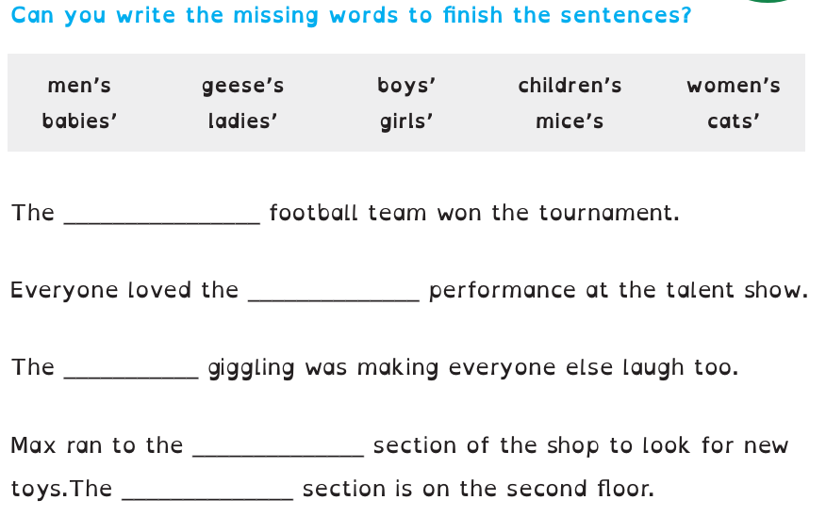
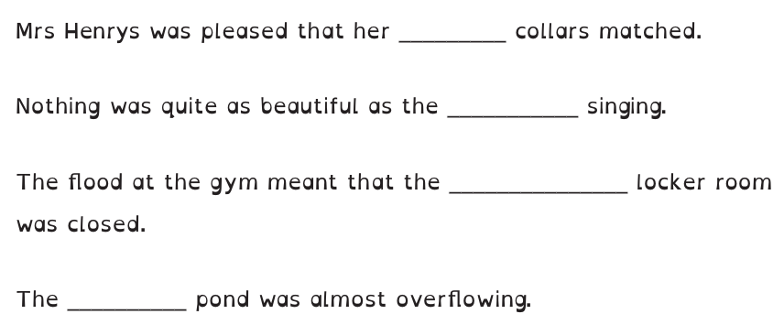
Year 3; To spell words that are plurals with possessive apostrophes



