Willow Class Homework- English; Date; 7/6/24
Year 2; To spell words with apostrophes for possession
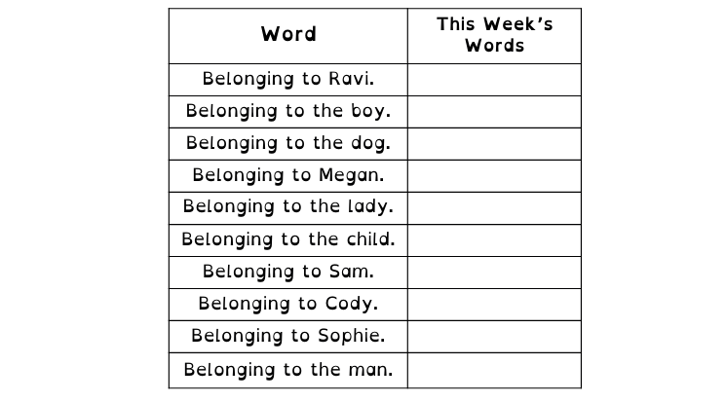
Words with apostrophes. Turn the statements into this week’s words.

Complete the sentences below by adding the correct word from the list;

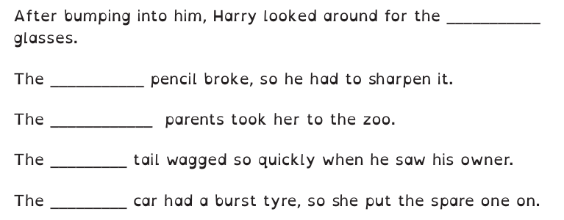
dog’s child’s boy’s lady’s man’s

Write a sentence about the pictures below. Remember to include the word in your sentence.


