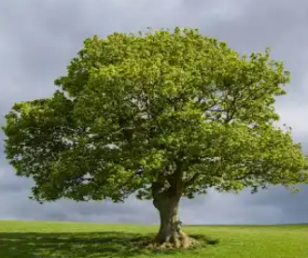
Home Learning Oak Class Friday 17th May
For our topic we are learning all about trees. This week we went for several walks to look at different types of tree. We’ve been reading about them too and learnt that there are two families of trees: broadleaved and conifer. Choose a tree of your own choice. It could be a tree you have in your garden or maybe one where you live. Draw it or take a photo, say which family it belongs to and describe what it looks like. Then write some facts about it.
Please hand in to be marked by Thursday 24th May

Home Learning Oak Class Friday 17th May
For our topic we are learning all about trees. This week we went for several walks to look at different types of tree. We’ve been reading about them too and learnt that there are two families of trees: broadleaved and conifer. Choose a tree of your own choice. It could be a tree you have in your garden or maybe one where you live. Draw it or take a photo, say which family it belongs to and describe what it looks like. Then write some facts about it.
Please hand in to be marked by Thursday 24th May

