Willow Class Homework- English; Date;26/4/24
Year 3; To spell words where ‘-ing’ ‘ed and ‘en’ are added to multisyllabic words
Choose 5 of the words below to write in a sentence, in your homework book, showing that you understand the meaning of the words. Remember, the doubled consonant.
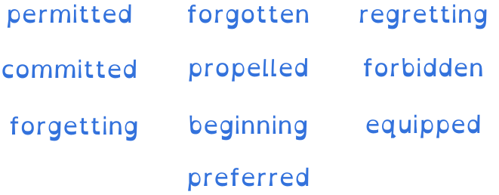

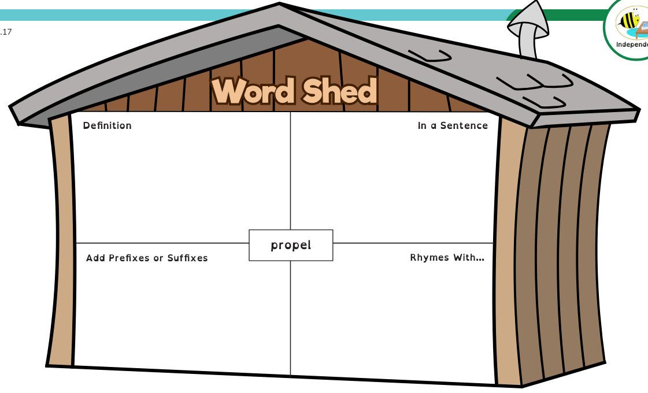
Now complete the word shed below;

