Willow Class Homework- English; Date;26/4/24
Year 2; To spell words where ‘-ing’ is added to single syllable words
Write a sentence about the pictures below. Remember to include the word in your
sentence.
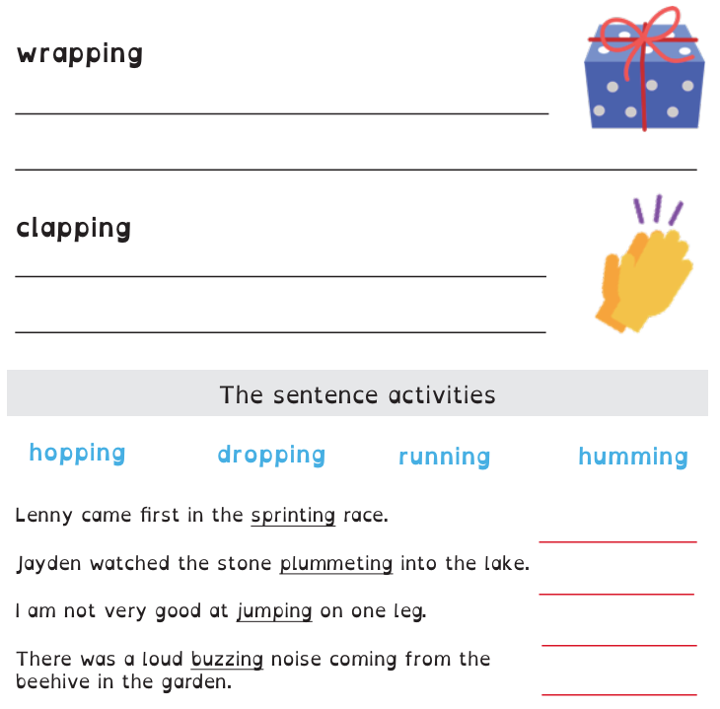
Then, complete the sentences.



