Willow Class Homework- Science/Geography; ‘The Water Cycle’ Date- 22/3/24
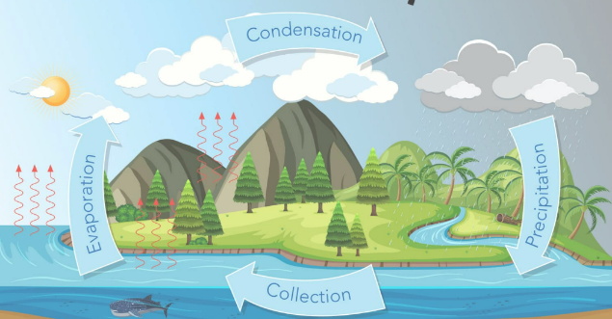
In our science and geography work this term, we have learnt that water can be a liquid, gas or solid. Outside, water is always changing from liquid to gas and back again. This process is called ‘The Water Cycle’.
The sun’s heat causes water to evaporate from streams, lakes, rivers, seas and oceans. The water vapour rises. When it reaches cooler air, it condenses to form clouds. When the clouds are full of water, or saturated, they release some of the water as precipitation. This is then collected back in the rivers and seas again.
For your homework, I would like you to make a 3d model to represent ‘The Water Cycle’. You can use any materials you would like (recyclable/re-usable if possible) but need to show clearly, and label, the different stages of the cycle. You can be as simple or as creative as you like in your design. Try not to make your model too big, so that you can bring it into school to display in the classroom.
Good luck
May I take this opportunity to wish all Willow class children, parents and carers a very happy Easter break.

