Willow Class Homework 8/3/24

British Science Week 2024; 8th – 17th March ; 30th Anniversary
10 Day Celebration of Science, Technology, Engineering and Maths
You all did some amazing online safety posters, Willow class and they look fantastic displayed in the classroom. Well done and thank you.
This week’s homework is again optional and involves creating another poster but this time as part of a National competition as part of British Science Week.
The theme this year is ‘time’. You could create a poster showing how a certain type of technology has changed over time, or even the advancement of time-telling technology itself. You might want to go futuristic and show how you think the world might look in years to come, or perhaps look at nature-lifecycles, lifespans, evolution and hibernation are all timely topics!
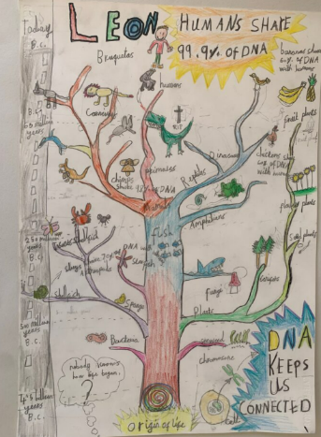
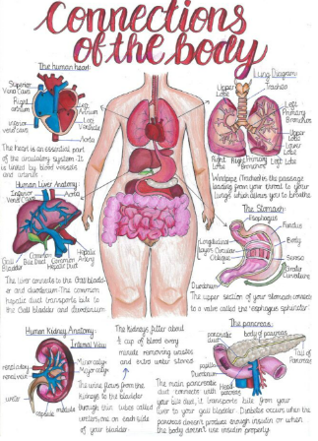
This is what the judges are looking for;
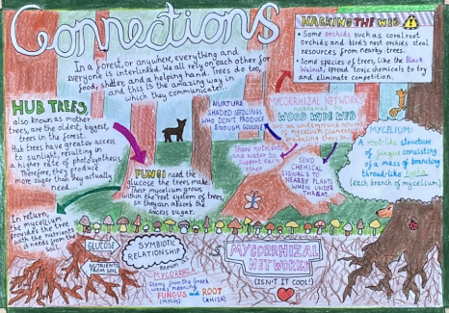
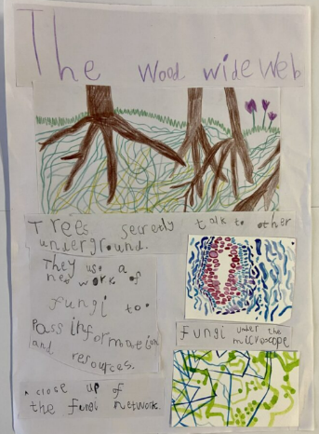

Above are some examples of winning posters, in different age groups, for 2023 when the theme was ‘Connections’.
If you decide to enter, please do not stick your poster in your homework book but bring it in to me in school where 5 from the school will be selected and entered.
Good luck!

