Willow Class Homework- English; ‘Using Apostrophes for Contractions’ Date- 23/2/24
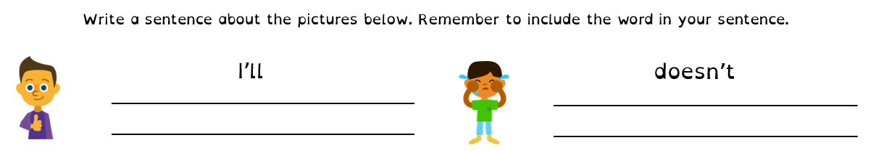
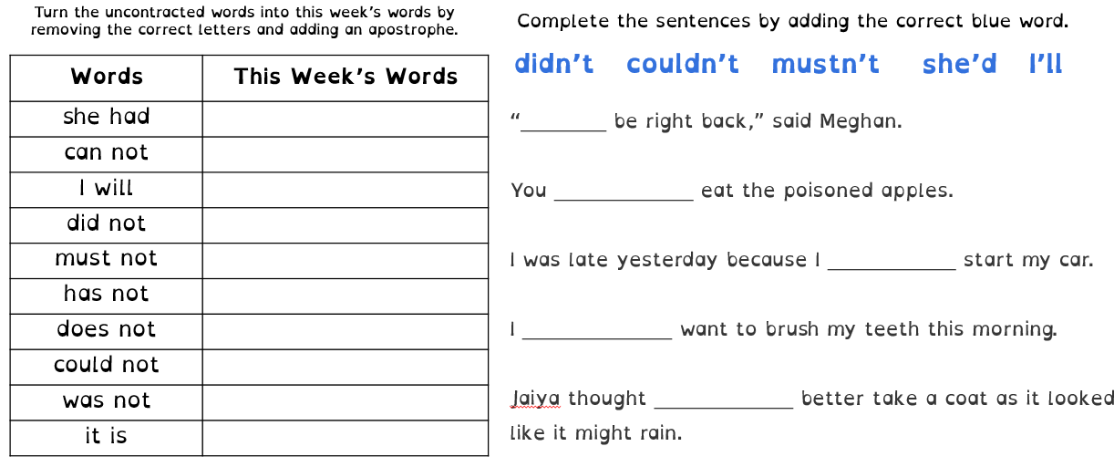
In our spelling work, we are learning to spell and use words with apostrophes for contraction. Be sure to put the apostrophe in the right place.
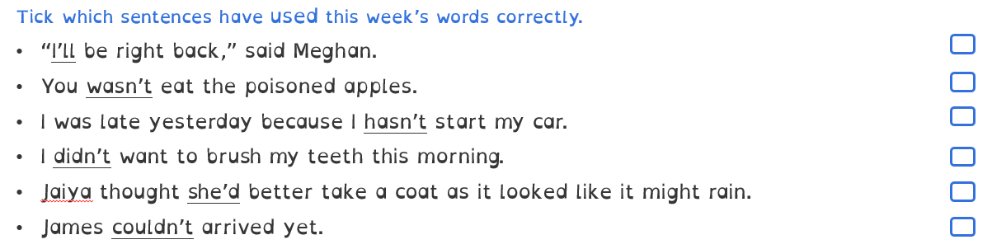
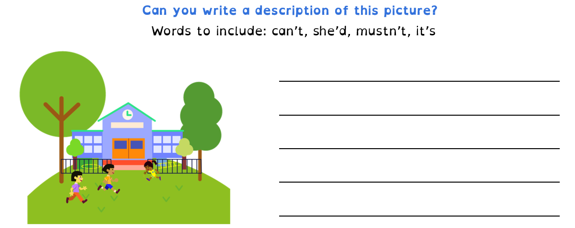
Challenge;

