Homework Term 4 Week 1
Due Tuesday 27th February 2023
10 minutes | Spellingshed  How many games can you play in 10 minutes?  Or practise your spelling words in another way  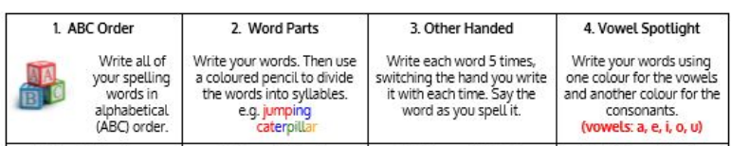
10 minutes | TT rockstars  Can you beat your studio time? How many coins can you collect in 10 minutes?  Have a go at using MTC - Multiplication Tables Check - URBrainy.com to try a time table challenge – 25 questions and 6 seconds for each!
10 minutes |   Design your own robot person like Christopher  What will it be able to do?  What makes it unique?  What does it look, sound ,act like?  How does it act?  What is its personality like?  Create a roll on the wall (like we did on Tuesday) to describe your Robot

