Willow Class Homework- English; ‘Homophones/Nr Homophones’ Yr 3 Date- 26/1/24
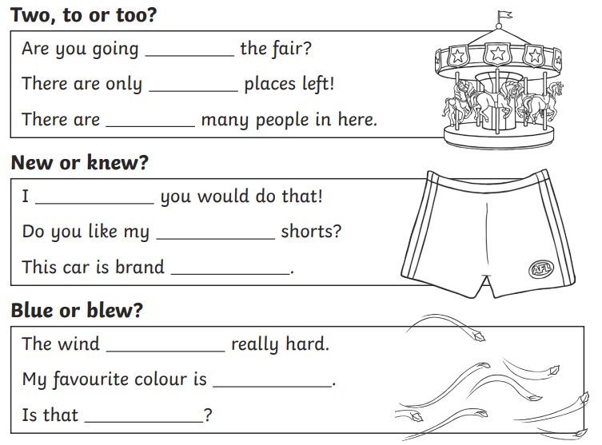
In our spelling work, we are learning to spell and use homophones and near homophones, which are words which sound the same (or nearly) but are spelt differently and have different meanings. Read the sentences below and choose the correct homophone to fill in the space.

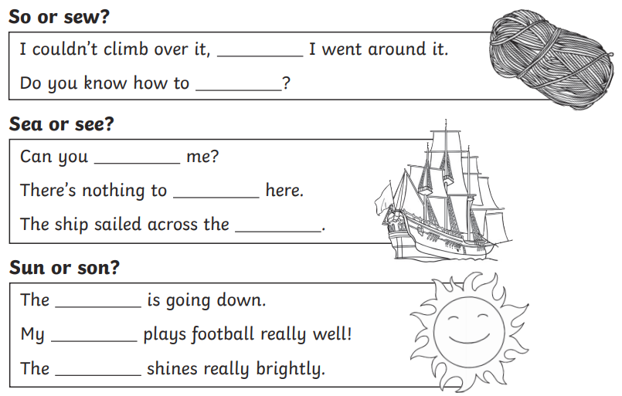

Match up the words from the grid below and make a list in your homework book of the words that are homophones or near homophones (words that sound the same or similar).
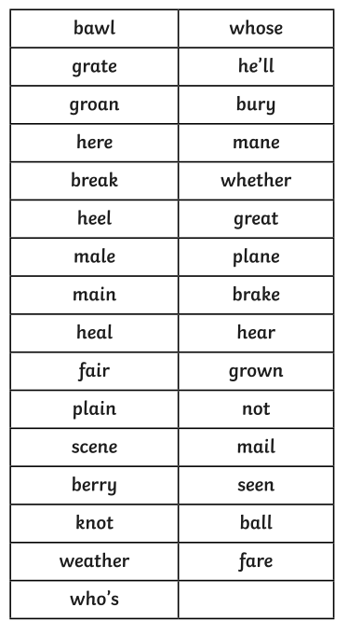
Clue; not all homophones come in pairs!

Challenge; Choose 3 homophones that you now know and write your own interesting sentences, using them correctly. Remember to use the correct punctuation.

