Willow Class Homework- English; ‘Homophones’ Yr 2 Date- 26/1/24
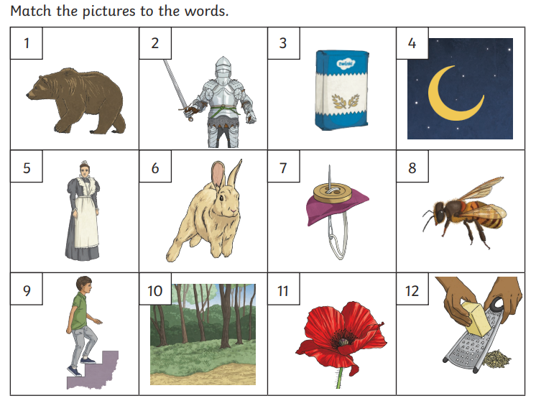
In our spelling work, we are learning to spell and use homophones, which are words which sound the same but are spelt differently and have different meanings.
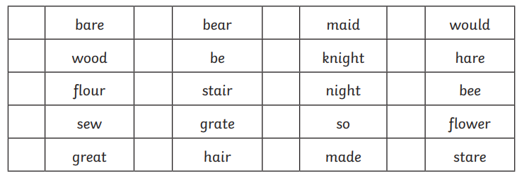

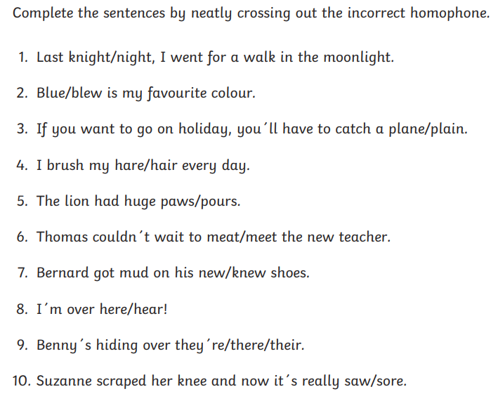
Challenge; Choose 3 homophones that you now know and write your own interesting sentences, using them correctly. Remember to use the correct punctuation.

