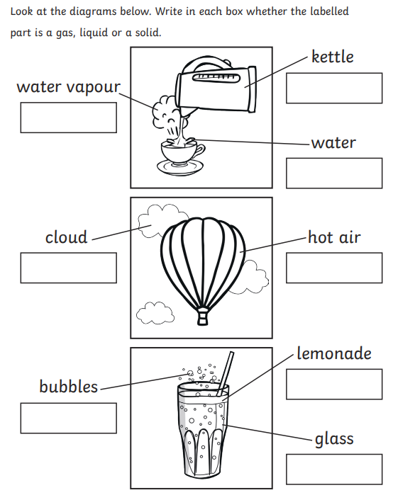
Willow Class Homework- Science; ‘States of Matter’ Date- 19/1/24

