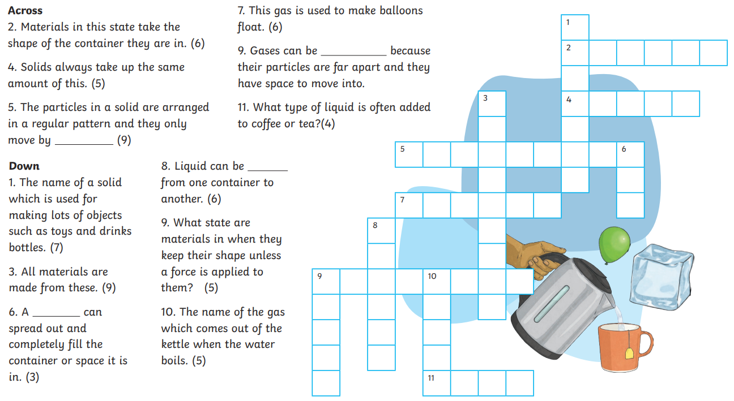
Read, or ask a grown up to help you, the clues to complete the crossword. All the answers are to do with solids, liquids and gases, which is our science learning this term.

