Willow Class Homework- Science; Different types of human teeth Date; 8.12.23
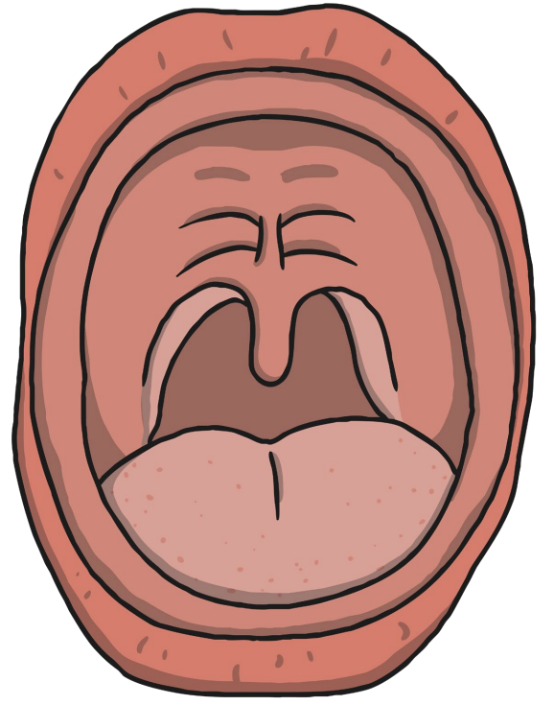
In Science, this week, we have been learning about the different types of teeth that we have as humans. Carefully, cut out the different types of teeth and stick them in the correct place in the human mouth. Please do not stick the finished mouth in your book.

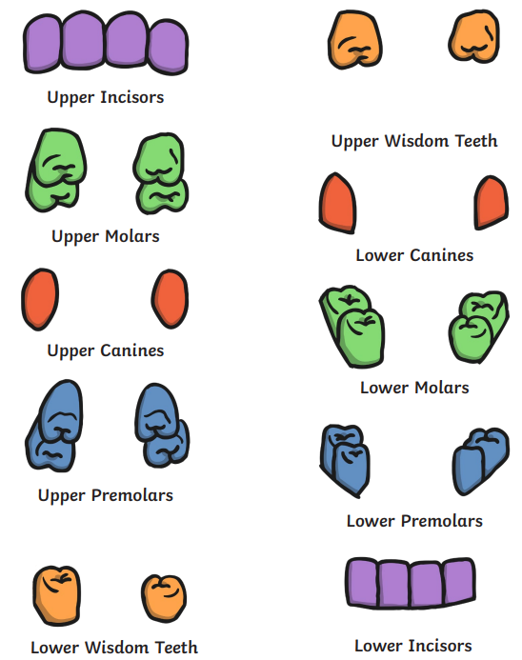
Challenge;
In your homework book, write down the function (job) of each of the different types of human teeth;
incisors, canines, premolars, molars, wisdom teeth

