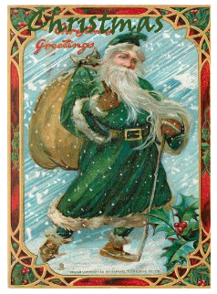
Home Learning Oak Class Wednesday 22nd November

For your home learning this week I would like:
Year 2s to practice the words for your speaking and singing parts for our Christmas performance Papa Duval’s Special Christmas.
Year 1s practice the words for the songs for our Christmas performance, Papa Duval’s Special Christmas.
Please can Year2s bring in their scripts every day so that we can practise together.

Home Learning Oak Class Wednesday 22nd November

For your home learning this week I would like:
Year 2s to practice the words for your speaking and singing parts for our Christmas performance Papa Duval’s Special Christmas.
Year 1s practice the words for the songs for our Christmas performance, Papa Duval’s Special Christmas.
Please can Year2s bring in their scripts every day so that we can practise together.



